**Activity 1**

**Understand the design of modular applications**

Modular application design is the process of dividing a complex system into smaller, independent components called modules. This method of design is very effective in building flexible and scalable systems, especially in the context of cloud-based applications. By dividing the system into standalone modules, developers can focus on making each part run independently, ensuring that the entire application remains manageable and adaptable over time. In our project, modular app design will be instrumental in ensuring that the cloud-based ShopEase app can efficiently process ecommerce big data.

Modular application design also enables work in distributed team environments, where each member or group can focus on different parts of the application simultaneously. This speeds up the development process and ensures that modifications or updates to a single module will not affect the entire system, reducing the risk of new bugs. In addition, this design supports reuse, which means that certain modules (such as product management or sales analytics) can be easily used in applications or Other projects, saving time and effort in future development.

**Key benefits of modular application design:**

* **Scalability**: As the application grows, the modular design allows individual modules to be added or modified without affecting the entire system. For example, in our e-commerce platform, a new feature such as a recommendation engine can be added by integrating a new module without affecting the existing system.
* **Ease of maintenance**: Each module can be updated or patched independently, making application maintenance simpler. This also means that if a problem arises in the notification system, the problem can be isolated and resolved without disrupting other parts such as product management.
* **Reuse**: Once the module is developed, it can be reused in different projects or contexts. For example, if we create an inventory management module, it can be used again in other e-commerce platforms.
* **Error isolation**: Because each module operates independently, errors or problems are limited to that module only. This helps easily identify the source of the problem and reduce the time required to fix it, ensuring the stability of the entire system.

**Splitting the system architecture into I/O modules:**

In modular system design, the system is divided into three basic modules: input, execution, and output. This division helps in the orderly and efficient distribution of tasks to ensure that data flows across the entire system in a logical and coordinated manner.

1. **Input unit**: The input module is one of the most important components because it deals with data from the different sources that the application handles. Its primary task is to collect and verify data before sending it to the execution unit for processing. The various sources that the input module may handle include application programming interfaces (APIs), external databases, as well as inputs provided by users via application interfaces.
   * **Data collection**: The unit is responsible for dealing with multiple sources of data such as products entered by customers, sales data that comes from points of sale, or analytical data collected from the system.
   * **Data verification**: After collecting the data, the unit has to ensure that the data collected is correct, whether it relates to customer or product information. You must ensure that the information is complete and accurate to ensure that the results on which you rely will be reliable.
   * **Data format**: The unit organizes data into formats that are easy to process. For example, you might need to convert units of measure or format numbers correctly.

This module plays a vital role in ensuring that the data sent to the execution module is fully ready, which means that it is the first line of defense against any errors that could affect the entire system.

1. **Execution unit**: An execution unit is considered as the "brain" in the system as it handles data processing and executing the underlying logic of the system. In a project like ShopEase, this module handles all transactions that the system makes, such as updating inventory or analyzing sales.
   * **Data** processing: The fulfillment unit receives data from the input unit and applies business logic to it. For example, if inventory is updated, the unit will deduct the quantities sold from existing inventory, or in the case of customer behavior, it will analyze purchase patterns.
   * **Interaction with databases**: A large part of the fulfillment unit's tasks is to interact with databases to store or extract data. For example, when a customer adds products to the basket, the inventory in the database must be updated immediately to ensure that the inventory data is always up to date.
   * **Data Analysis**: The module also analyzes data to provide detailed reports such as sales reports and customer behavior analytics. These analytics may be used to improve marketing strategies or improve inventory management.

The execution module aims to process data at full speed and accuracy, ensuring that the results provided to the next module (output) are accurate and reliable.

1. **Output Unit**: The output unit is responsible for displaying the results and data after processing them by the execution unit. It is the face that the user deals with in the end, as he receives the results of the system's work, whether through notifications, reports or graphs.
   * **View results**: This module provides results that have been processed by the fulfillment module in an understandable and user-friendly manner. For example, it can display reports on available inventory or alerts about products that need to be restocked.
   * **Notifications**: One of the primary features that an output module can offer is to send real-time notifications. These notifications can be related to any change that occurs in the system such as product outouts or a change in prices. These notifications are intended to keep users up to date with important changes.
   * **Generate reports**: The module also generates detailed reports that can be used by management to make strategic decisions. For example, it can provide reports on sales performance over a certain period or analyze customer buying patterns.

Modular design and cloud integration: The modular design is ideally aligned with cloud computing. The cloud enables each module to be hosted, updated, and maintained independently while taking advantage of the scalable nature of cloud infrastructure. A cloud-hosted ecommerce application can augment its individual modules such as a product catalog or on-demand notification system without impacting overall application performance. In our project for ShopEase, integrating the modular system into  **the cloud means**  that cloud computing benefits such as flexibility, scalability, and cost savings can be exploited. Each unit operates independently and leverages cloud resources according to current needs, making it easier for the system to handle the increase in data volume and requests.

1. **Scalability:** When data volume or number of users increases, the cloud can provide additional resources quickly and flexibly. For example, if the number of products uploaded into the product catalog increases or the number of customers using the site simultaneously, the cloud can provide additional processing resources to support this increase. This boosts overall application performance and prevents any system slowdown.
2. **Manage units independently:** The modular design allows the management and maintenance of each unit individually. For example, updates can be made to the notification module or analytics module without having to shut down the entire system. This integration between different units in the cloud environment is done easily, making the process more efficient and less vulnerable to technical issues.
3. **Security and cloud storage:** With cloud services, data can be better secured by leveraging the advanced protection technologies provided by cloud infrastructure. Data such as customer data, sales records, and market analytics are stored in secure databases within the cloud, ensuring that data is protected from cyber threats.
4. **Seamless integration between modules: The** cloud allows the provision of application programming interfaces (APIs) that help to easily connect different modules within the system. For example, the output module can communicate with the analysis module via API to retrieve reports in real time and view them to end users smoothly and quickly. The integration of these modules into the cloud means that processes are done faster and more efficiently.
5. **Resource Management:** Cloud infrastructure helps distribute the load on multiple servers to avoid overloading any unit in the system. Resources are employed as needed and dynamically, reducing waste and enhancing operational efficiency. In addition, the cost of using the cloud can be controlled by paying only a fee for resources that have already been consumed.
6. **Maintenance and periodic updates:** Thanks to cloud computing, updates and maintenance can be performed in seamless ways without service interruption. For example, if improvements to the notification module or new features are needed for the analytics module, these changes can be made in the background without affecting the user experience or system downtime.

The modular design integrated with cloud computing gives the system great flexibility and quick response to the growing needs of the application. The system can scale according to business requirements, leveraging the cloud to enhance security and operational efficiency, making it an ideal solution for any application that needs high reliability and performance in a fast-growing environment such as e-commerce.

**I/O module design**

In this section, we'll explain the design and architecture of the application by breaking it down into the main components: **the input module**, the **execution module**, and the output module. We will also provide  **a category diagram** and a **UML diagram** to explain how these modules interact with each other and with the system as a whole. The goal is to ensure a modular design that allows for scalability, ease of maintenance, and integration with the cloud.

**Explanation of the design of each unit**

1. **Input Unit**:
   * **Objective**: The primary role of the input unit is to collect and validate data before it is processed into the system.
   * **Functions**:
     + Collects data such as customer information, product details, and notifications from users or administrators.
     + Data is validated to ensure that it is correct and complete before it is processed or stored in the database.
     + **Example**: The customer module collects customer information such as name, contact details, and addresses. Similarly, the product module allows administrators to enter product data such as type, size, color, and inventory levels.
2. **Implementation Unit**:
   * **Objective**: The implementation unit handles all data processing and logic execution within the system.
   * **Functions**:
     + This module performs basic operations such as adding new customers, updating product details, generating reports, and analyzing customer behavior.
     + It also includes the function of sending notifications to subscribers when new products are added or updated.
     + **Example**: When you add a product, the system processes product data, sends a notification to all subscribers, updates the notification database and triggers alerts.
3. **Output Unit**:
   * **Objective**: This unit is responsible for providing final outputs such as notifications, reports, and analysis results.
   * **Functions**:
     + The output unit interacts with the database to retrieve processed data and provide it to users in a useful form, such as reports or notifications.
     + It can produce real-time notifications, sales reports, and product trends to ensure that users get accurate and timely information.
     + **Example**: The Notifications module sends notifications to customers when new products are added. The Analytics module generates sales reports and analyzes customer behavior based on stored data.

**Modular structure and integration**

By dividing the system into modular components (I, Execute, and Output), the application gains flexibility and scalability. Each module operates independently, allowing separate tests, updates, and improvements to be performed without affecting the entire system. This modular is in line with the nature of the cloud-based application, where different modules can be scaled and their performance improved as needed.

**Categories Chart**

To explain the modular structure of the application,  **the following category diagram shows the**  base classes in the system along with the associated methods and attributes. This chart reflects the modular division of the system:

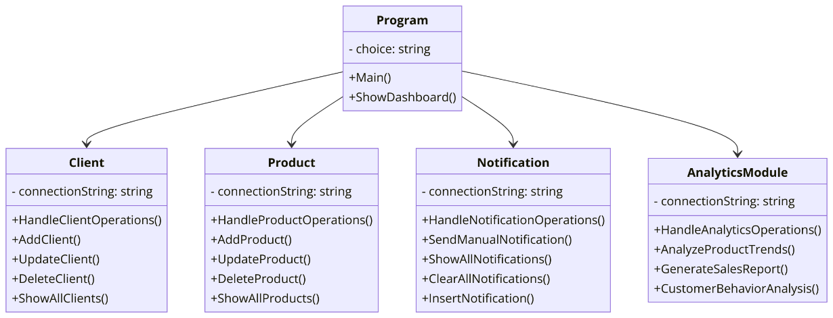

* **Program category**: Acts as a primary entry point for the application, allowing navigation between modules.
* **Customer, Product, Notifications, and Analytics Module Categories**: These units are responsible for customer management, product management, notifications, and analytics respectively.
* **Methods**: Each category contains methods that are responsible for managing operations such as adding, updating, and deleting data from a MySQL database, as well as creating notifications and reports.

This scheme represents the internal classes of the system and the relationships between the basic components.

**UML diagram of unit interaction**

The following **UML diagram shows** a high-level view of how different units interact within the system. This chart shows the flow between the main control panel and the different units, including the database and notification flow:

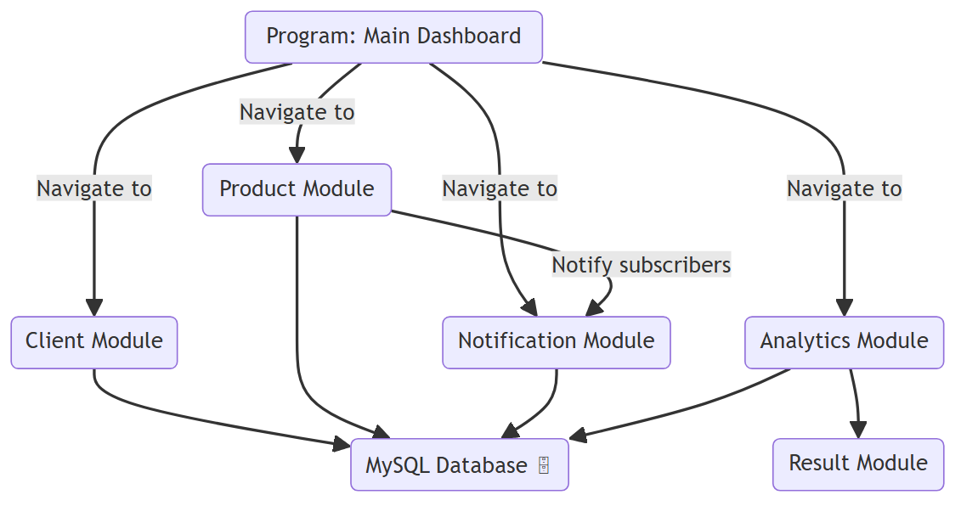

* **Software (main control panel):** The entry point of the application where users navigate between different modules.
* **Customer, product, notifications, and analytics modules**: Each module is connected to the dashboard and interacts with the database to store and retrieve data.
* **MySQL Database**: Centralized to all operations, storing data about customers, products, and notifications.
* **Notification flow**: The chart shows how to turn on notifications from the product unit and send them to all subscribers via the notifications module.

This chart helps visualize the flow of data and how units work together to complete tasks such as customer management, product management, and analytics reporting.

**Cloud integration (conceptual overview)**

Cloud integration plays a pivotal role in supporting the modular application architecture, as cloud services provide a flexible and scalable environment that facilitates hosting and updating system modules independently. This allows the application to efficiently handle the increase in data volume and the number of users. Cloud integration boosts performance by dynamically distributing loads, ensuring a quick response to market changes and demand. In addition, the cloud provides a high level of security for customer data protection and analytics, with continuous backup and data recovery. Easily when needed. This cloud architecture ensures that each system unit, such as a notifications or analytics module, can scale and be flexibly managed without affecting the overall efficiency of the application.

The design of this modular application ensures that each component (I, Execute, and Output) is independent, scalable, and easy to maintain.  **The class diagram** and  **UML diagram shown above provide a comprehensive representation of how the system is structured, how the modules interact, and how data flows within the application. This modular method of design is essential to achieving the scalability, flexibility, and efficiency required for cloud-based applications like** ShopEase.

**Linking units together in the modular system**

We'll walk through how the new product notification system works in **ShopEase**' s eCommerce app. The system revolves around adding new products to the database, and then sending instant notifications to all registered subscribers to let them know that new products exist. Each process is carefully coordinated to ensure integration between the I/O modules.

Through the illustrations, we will explain in detail how the system works from product input, through updating the database, to sending notifications to subscribers.

**Process details with pictograms:**

**New Product Data Entry:**

Initially, the user enters the details of the new product through the user interface. Required fields include type (e.g.: shirt, shoes), size (S, M, L...), color (red, blue...) , price, and quantity of available inventory.

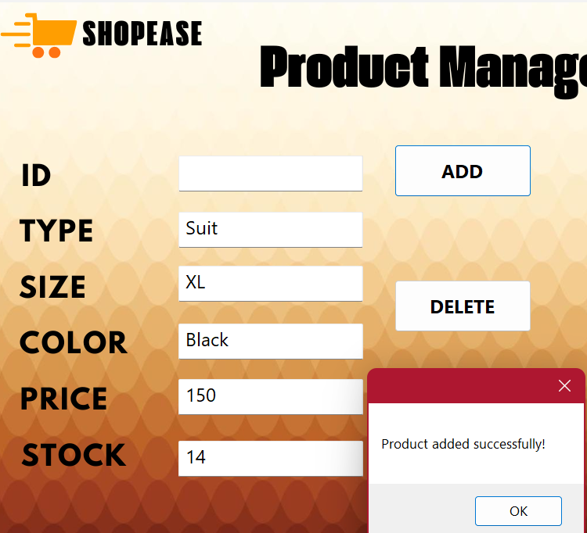

This part appears in the first image, showing the interface for adding the product in the system. The fields are filled in accurately to ensure that the new product contains all the required information. This entry is sent to the system to be stored later in the database.

**Update the database:**

After confirming that the entered data is correct, the system performs the process of storing this information in the database. In the second image, we see how the new product is added to the products table in the database.

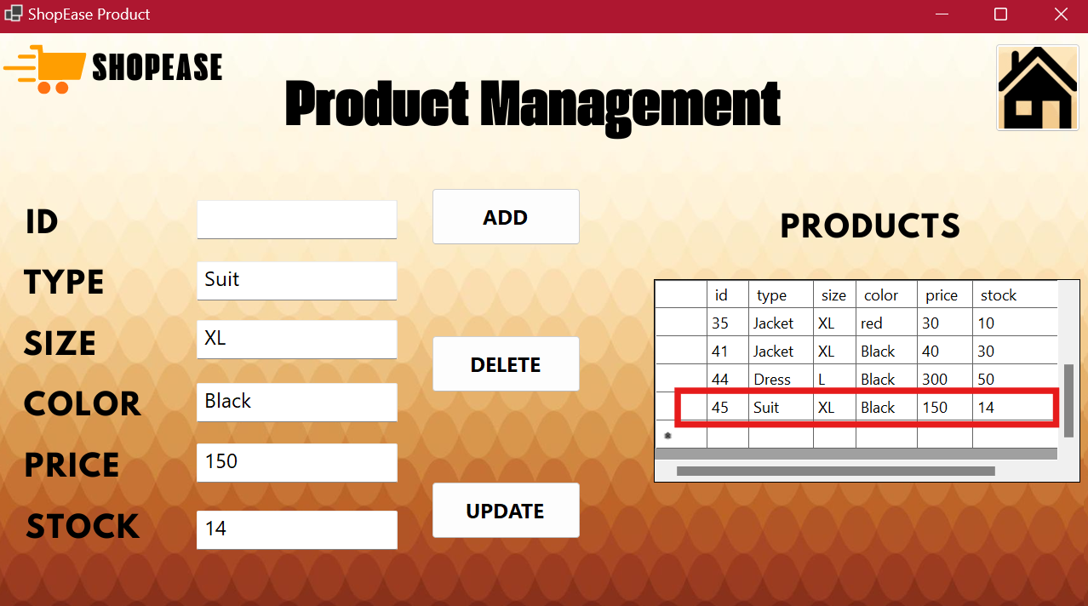

A SQL **query is sent** to the database, and the system registers the product with the specified details. This step ensures that the new product is available for review and request by customers.

**Fetch subscriber names from the database:**

In this step, the system fetches the names of all subscribers who want to receive notifications of new products. Another SQL query is executed to fetch a list of registered subscribers from the subscribers table.

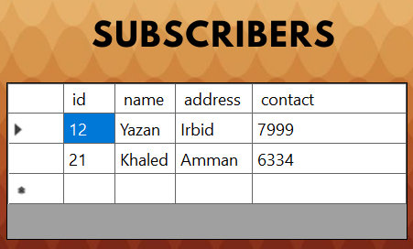

**Send notifications:**

After processing the names of the subscribers, the system sends a notification containing the details of the new product. The notification includes the type, price, color, and quantity of available inventory. The fourth image shows how the system sends notifications to each subscriber using the newly added product data.

Notifications are also saved in the database, where users can later review them through a special section of the system.

**View notifications:**

The last image shows how subscribers can view the notifications they received about new products. This interface displays all notifications in an organized manner, allowing subscribers to know the latest added products and available offers.

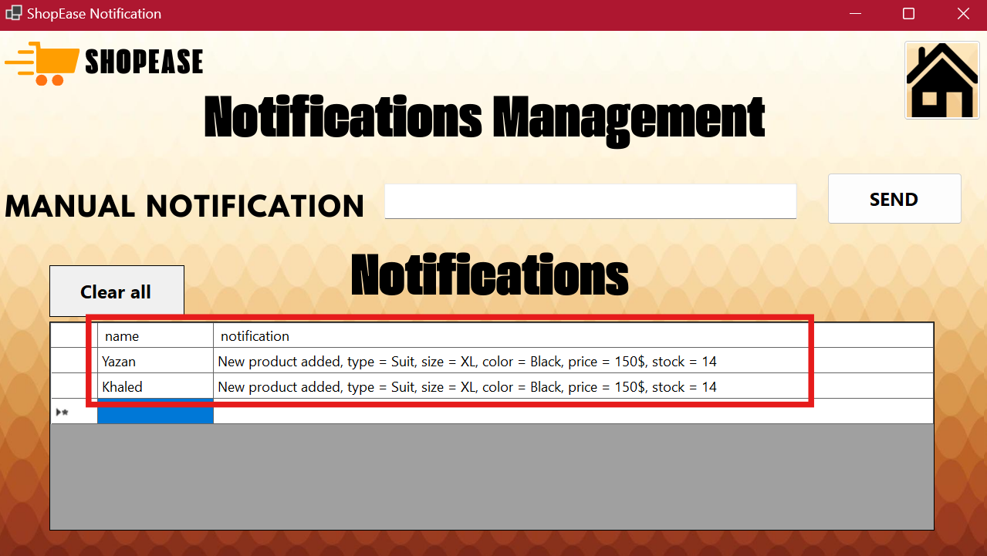

The system offers a seamless and integrated process to ensure that all subscribers are informed of new products immediately. Processes are broken down into clear steps, where the product is added first and then notifications are sent after the database is updated, ensuring a quick and efficient response while maintaining the integrity and flexibility of the system.

**Use cloud computing across AWS in your ShopEase project**

In **the ShopEase** project, developed by **OptiCloud Solutions Inc.**, integration with cloud computing is an essential step to ensure high performance, scalability, and security in handling large amounts of data in a fast-growing e-commerce environment. With the use of **Amazon Web Services (AWS), you** can be assured that the application runs efficiently around the clock, with great flexibility in adapting to sudden changes in the number of users or data volume.

**استخدام AWS Elastic Compute Cloud (EC2)**

AWS EC2 is the cornerstone of the cloud computing architecture of any system that relies on virtual resources. In the context of  **a ShopEase** project, **EC2 can** host the entire application, including the user interface and back-end servers that handle real-time product and customer management, and notifications. By leveraging EC2's flexibility, the development team can configure multiple virtual servers according to the size of the demand.

For example, at peak times such as holiday seasons, the number of users interacting with the system can double. With EC2, the project can automatically configure servers to meet this increase in demand through **the Auto Scaling** feature. This ensures that the application does not experience any interruptions or performance degradations. In addition, AWS provides a variety of instance types options, ranging from low-cost instances for development and testing, to high-performance instances to handle production and interact with large amounts of data.

**استخدام Amazon RDS (Relational Database Service)**

In the ShopEase project, the system relies heavily on a robust and flexible database to store and manage big data related to products and customers. With **Amazon RDS**, we can replace the on-premises MySQL database that was used in the on-premises application with a fully managed database on the cloud. RDS enables the management of all aspects of databases, such as backup, restore, and scaling automatically.

For example, RDS can seamlessly manage database expansion when the data volume increases, without the need for manual intervention from the development team. In the scenario for ShopEase, where new products are added and updated regularly, RDS provides a stable and integrated environment that ensures high performance and responsiveness. The use of security features such as automatic encryption and security updates in RDS ensures that customer and user data is effectively protected.

**استخدام AWS S3 (Simple Storage Service)**

For a project like ShopEase, which may need to store a large amount of files such as product images and analytical reports, **Amazon S3**  is an ideal option for efficiently storing unstructured data. S3 can accommodate and store all types of large files at a low cost while making them easily accessible via software interfaces (APIs).

In a ShopEase project scenario, product images and data analysis can be stored in S3, allowing quick access both by end users and through background processes performed by the system. Images can be uploaded to S3 through a software interface, and then used in the user interface to deliver newly added product images. This flexibility in data storage and access is one of the most important features of S3, and helps improve the loading speed of pages and user data.

**استخدام AWS SNS (Simple Notification Service)**

The newsletter system in the ShopEase project is an essential part of the app, where instant notifications are sent to customers when new products are added or existing ones are updated. **AWS SNS** is a messaging service that allows notifications to be sent to a large number of customers through several channels such as email or SMS.

In this context, ShopEase can use AWS SNS to distribute notifications to subscribed customers instantly, ensuring that they receive notifications in real time. For example, when a new product is added to the database, SNS can send a message to all subscribers informing them of product details. This service is very useful to ensure instant customer interaction with the system, contributing to improving the end user experience and increasing customer satisfaction.

**Use AWS Lambda**

**AWS Lambda** provides serverless computing, where code runs only when needed, without the need to run a server permanently. **Lambda**  can be used in a ShopEase project to manage small and repetitive processes such as sending notifications when products are updated in the system.

For example, instead of running a permanent server to send notifications, Lambda can run short code that sends notifications using SNS every time a new product is introduced or updated. This reduces the overall cost of the system, as only the resources used are paid for during the code execution life, and reduces the complexity of server management.

**استخدام Amazon CloudWatch**

**Amazon CloudWatch** is a real-time monitoring tool that collects data and metrics from various AWS services. They can be used to monitor system performance and detect any potential problems. In the ShopEase project, **CloudWatch can monitor**  EC2 instances, databases in RDS, and notification status in SNS.

For example, if a delay is detected in sending notifications, CloudWatch can send an alert to the development team so they can step in and resolve the issue. In addition, database performance can be monitored through CloudWatch to ensure that the system is running at maximum efficiency and there is no slowdown in data queries.

**The overall benefits of using AWS in a ShopEase project**

**a) Improved performance and scalability**

With tools like EC2 , RDS, and Auto Scaling, system performance can be greatly improved. These tools allow resources to be automatically scaled up when needed, ensuring that service is uninterrupted even at peak times. Easy scalability makes the system flexible and able to accommodate a sudden increase in users or data without affecting performance.

**b) Security and reliability**

AWS provides a comprehensive suite of security tools such as IAM, VPC, and Security Groups. In the ShopEase project, these tools can be used to protect sensitive data such as customer and product information. In addition, AWS provides built-in encryption and automatic backup features to protect data from loss or theft.

**c) Easy integration with other AWS services**

By using SNS, Lambda, S3, and CloudWatch, ShopEase can easily integrate various system components. This integration makes managing repetitive processes such as notifications and analysis more effective and easy, enhancing the system's responsiveness to users' needs.

**d) Improve user experience**

With instant notifications using SNS, improved performance with EC2 and RDS, and a seamless experience across S3, ShopEase enables users to have a seamless and flexible experience. Users can receive instant notifications about new products and enjoy fast app performance regardless of data size.

**The bottom line**

Using AWS in your ShopEase project greatly enhances performance, flexibility, and security. By exploiting services such as EC2, RDS, S3, Lambda, and SNS, system efficiency can be improved and an outstanding experience for end users is ensured.

**Activity 2**

**Product Model Test and Implementation Plan**

At this stage, a thorough testing of the **product model was carried**  out to ensure its functionality, reliability and stability under various scenarios. The tests focused on:

1. **Input validation tests**
2. **Error Handling Tests**
3. **Working with empty data**
4. **Unusual input scenarios**

**Input validation tests**

The product model **is designed**  to validate key fields (such as product type, size, color, price, and inventory) before allowing any operations such as adding, updating or deleting a product.

**Key scenarios:**

* **Check the length of the product name**: The length of the product name (type) should not exceed 50 characters.

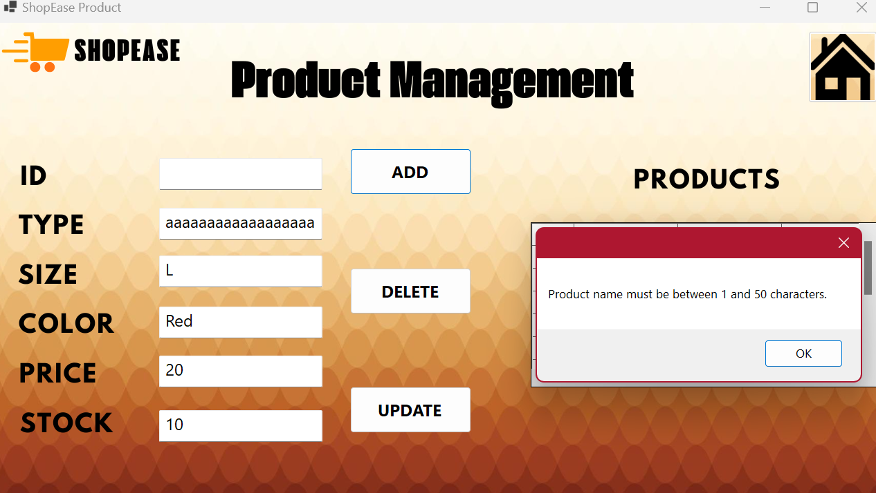

* + **Testing**: I tried to add a product whose name exceeds 50 characters.
  + **Expected result**: The system displays an error message that prevents the product from being added.
  + **Result**: **Succeeded** – the system prevented incorrect entry and showed an appropriate message.
* **Price and inventory check**: The entered values for price and inventory must be numeric.

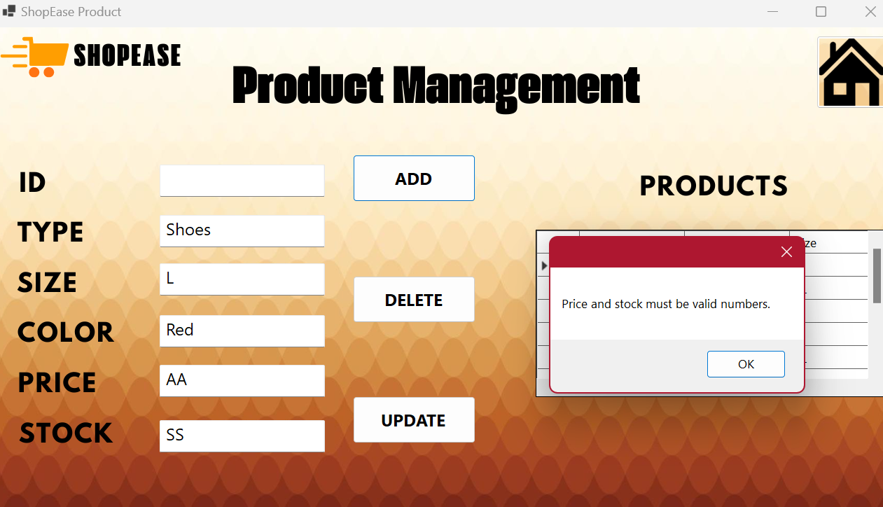

* + **Test**: You tried to add a product with non-numeric values in the Price or Inventory fields.
  + **Expected result**: The system displays an error message and stops completing the operation.
  + **Result**: **Succeeded** – the system detected invalid data and showed a message requesting to correct the entry.
* **Check positive values**: Price and inventory values must be greater than zero.

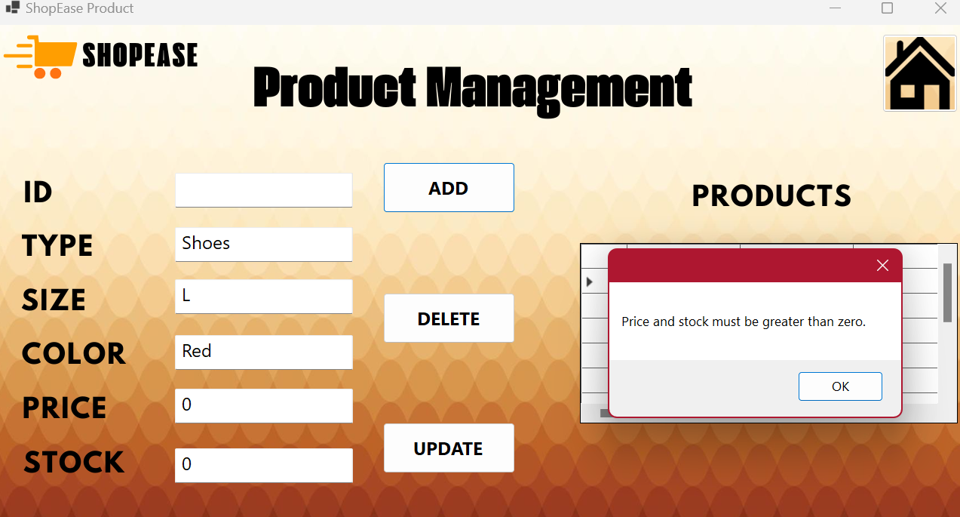

* + **Test**: You try to add a product with a price or inventory value less than or equal to zero.
  + **Expected result**: The system rejects the input and displays an error message.
  + **Result**: **Succeeded** – the system detected incorrect values and showed an appropriate message.
* **Check special characters in the color field**: The color field must contain only characters and spaces.

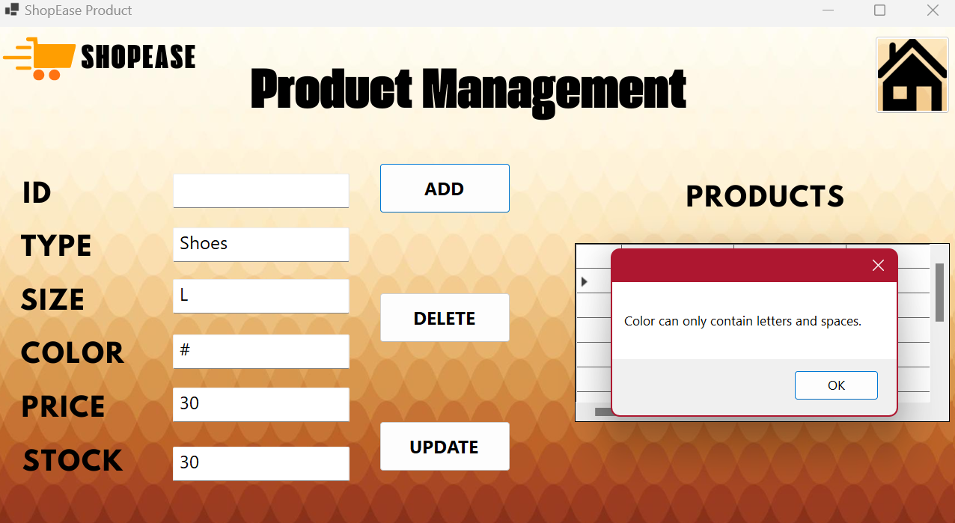

* + **Test**: You entered special characters such as # and @ in the color field.
  + **Expected result**: The system displays an error message and prevents the user from proceeding.
  + **Result**: **Succeeded** – the system prevented invalid input and showed an error message.

**Error Handling Tests**

It has been tested how the system responds to system-wide errors such as database disconnection during operations.

**Key scenarios:**

* **Database disconnection**: The system response was tested when connection to the database was not available during operations.

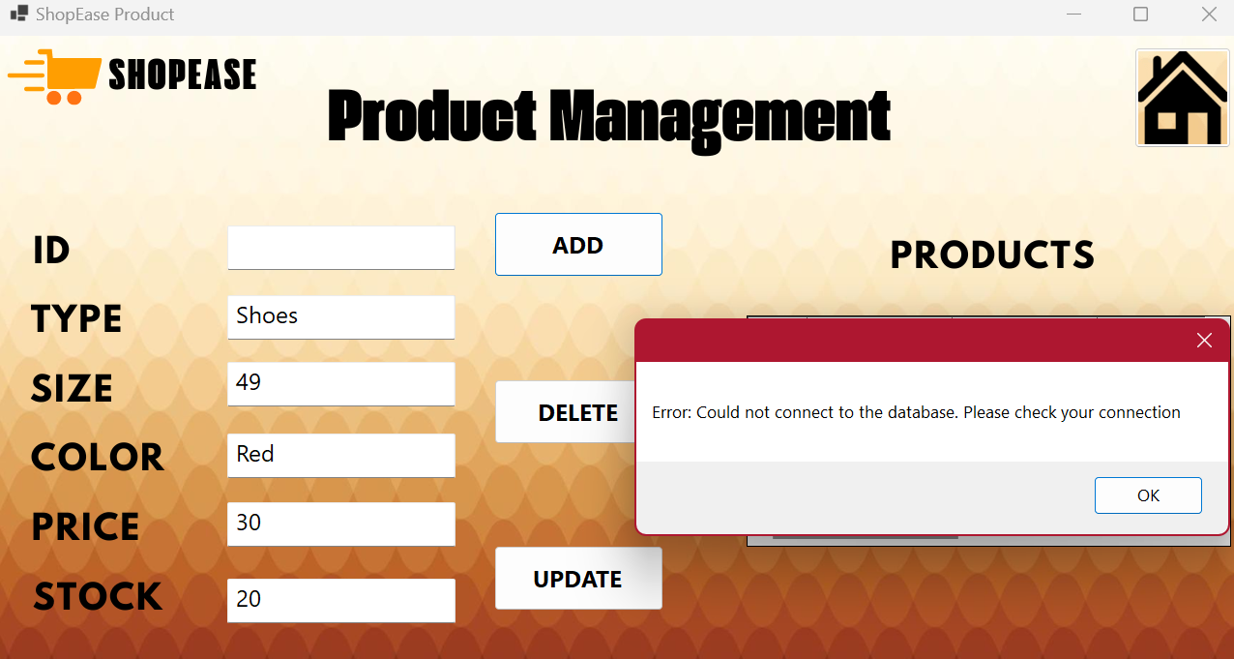

* + **Testing**: You disconnected from the server while trying to add a product.
  + **Expected result**: The system displays a clear error message without crashing or freezing.
  + **Result**: **Succeeded** – the system handled the disconnection smoothly and informed the user of the problem.
* **Easy-to-understand error messages**: Make sure the system displays clear error messages to users instead of technical details.

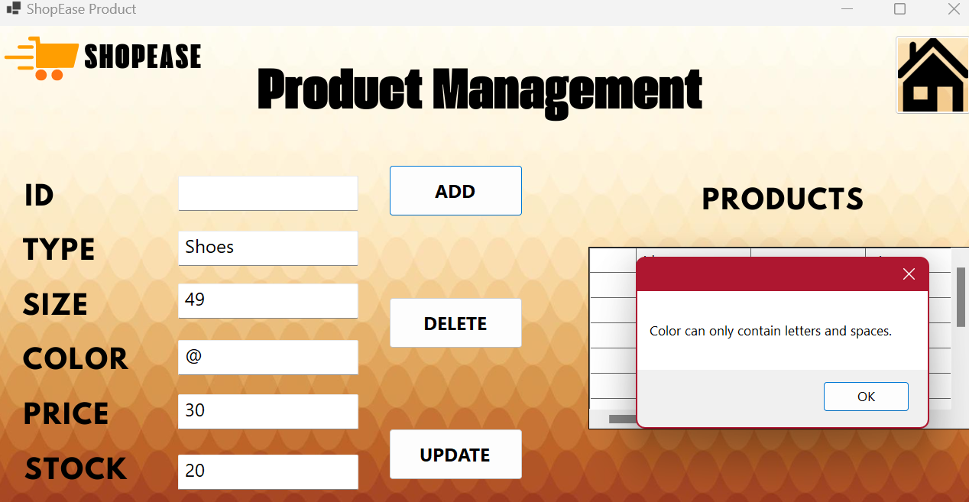

* + **Testing**: Various errors were simulated during product processes (adding, updating, deleting).
  + **Expected result**: The system displays clear error messages and provides instructions to the user.
  + **Result**: **Succeeded** – the system displayed understandable error messages to the user.

**Working with empty data**

Dealing with blank data was crucial to testing how the system responded when the required data was absent.

**Key scenarios:**

* **Check for primary fields**: Base fields such as type, size, color, price, and inventory should not be empty.

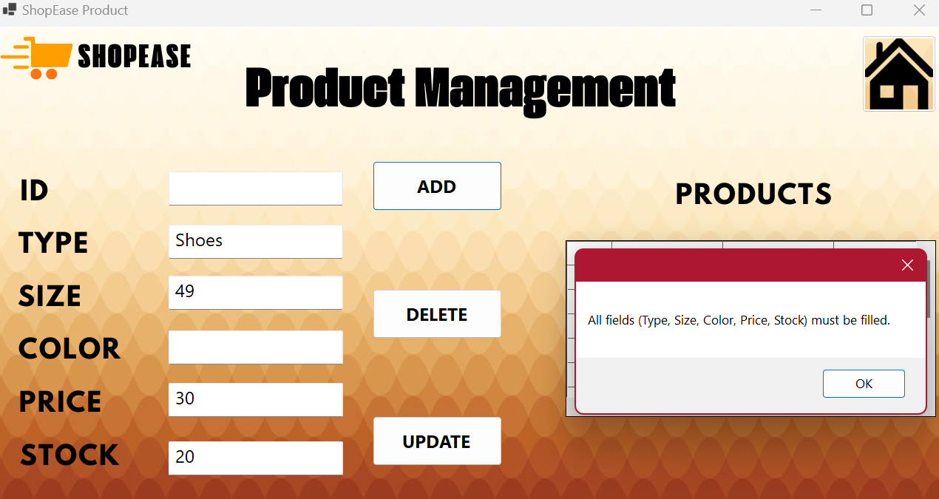

* + **Test**: You tried to add a product but left one or more of these fields blank.
  + **Expected result**: The system displays an error message and does not continue the operation.
  + **Result**: **Succeeded** – The system detected empty fields and showed an appropriate error message.
* **Try to update a product without identifying an ID**: You tried to update a product without identification.

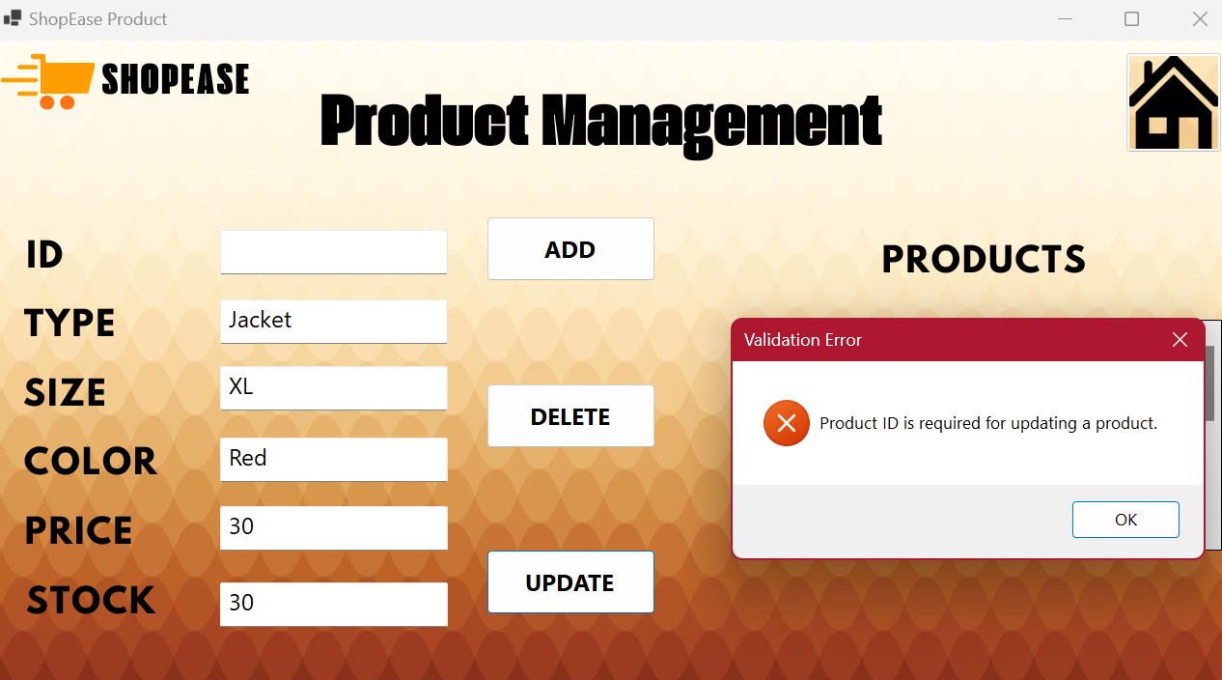

* + **Testing**: You left the identity field blank while trying to update the product.
  + **Expected result**: The system refuses to update and asks for ID entry.
  + **Result**: **Succeeded** – the system prevented the update due to loss of identity.

**Unusual input scenarios**

How the system responds to unusual input behaviors has been tested to ensure that it is stable under unexpected input.

**Key scenarios:**

* **Enter special characters in fields**: You enter special characters in fields such as price and quantity.

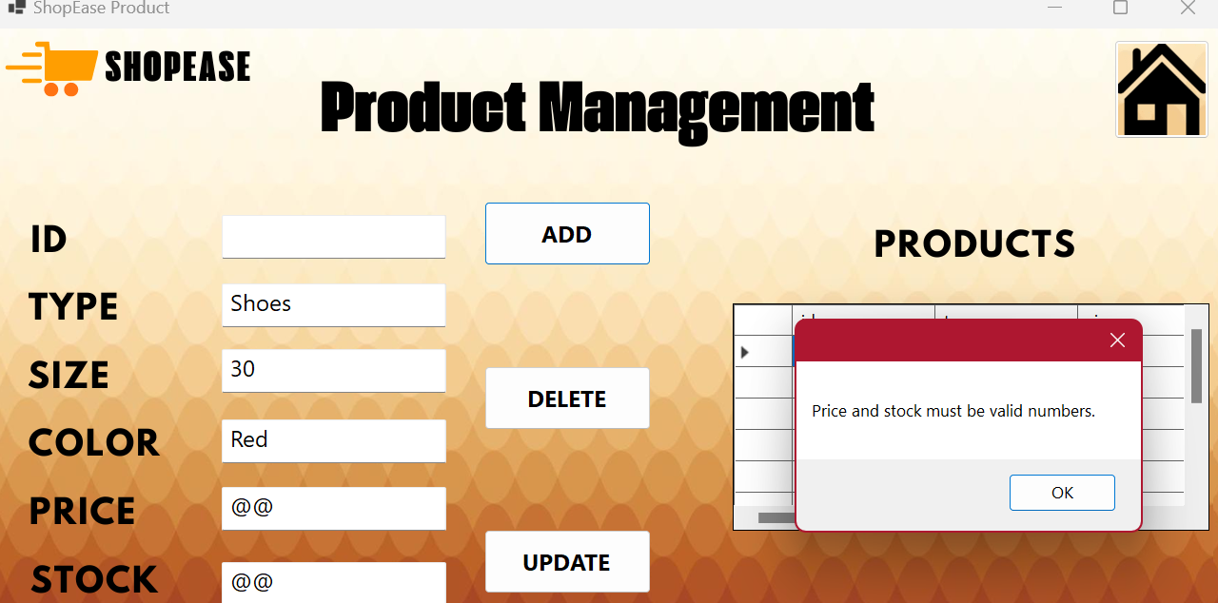

* + **Testing**: I tried to add a product in special letters in the Price and Quantity field.
  + **Expected result**: The system displays an error message and blocks the operation.
  + **Result**: **Succeeded** – the system rejected the incorrect entry and showed an appropriate message.

The testing phase confirmed that  **the product model** has the ability to handle a variety of scenarios, while providing clear and actionable feedback to the user. The application effectively validates inputs, handles errors seamlessly, and responds to missing or incorrect data with appropriate messages.

**Introduction Demo Code (Stub Code)**

Demo code plays a vital role in agile development environments such as the modular cloud application we are developing for OptiCloud Solutions Inc' s ShopEase platform. Demo code provides a framework for simulating the behavior of key system components before they are fully integrated with databases or live cloud services. This allows developers to focus on each module independently, ensuring that each module works as expected.

I will provide a detailed explanation of the pilot code for each module—the customer management unit, the product management module, the notification system, and the analytics module—along with analyzing its outputs and the benefits associated with using the beta code in this scenario.

**Code Explanation: Customer Management Unit**

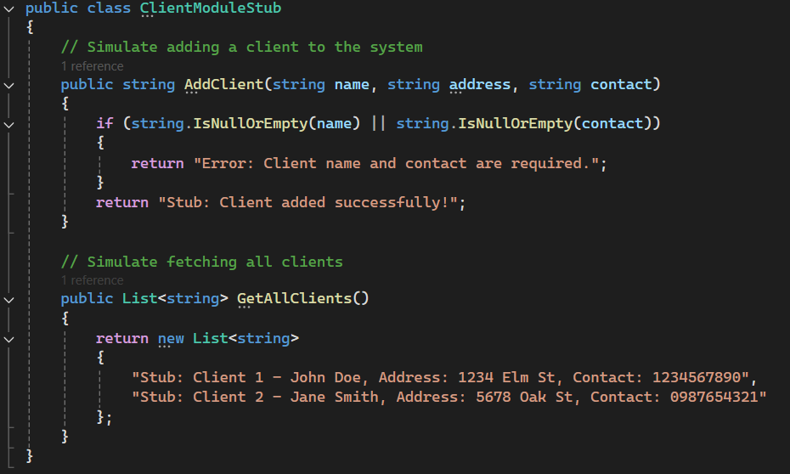

**Add Client: The** AddClient method simulates adding a client by checking the required fields such as name and contact information. If any of the fields are missing, they return an error message to make sure that the correct verification exists. If all the fields are correct, the system simulates the successful addition of the client and returns a message confirming the addition.

**Fetch customers:** The GetAllClients method returns a list of customers without an actual query from a live database. This makes it easier for developers to test the logic of displaying data.

**Code Explanation: Product Management Unit**

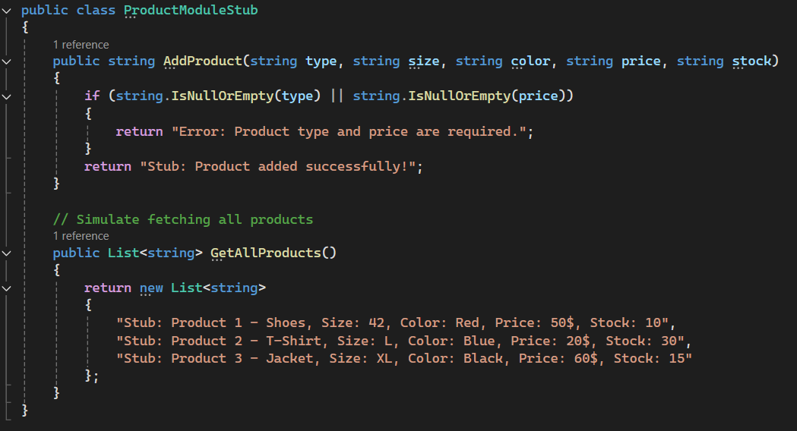

**Add product**: The AddProduct method simulates adding a product. The product type and price are verified, and if these fields are missing, they return an error message, ensuring correct verification before adding the product.

**Fetch products**: The GetAllProducts method returns a list of products, making it easier for developers to simulate data display.

**Code Explanation: Notification System**

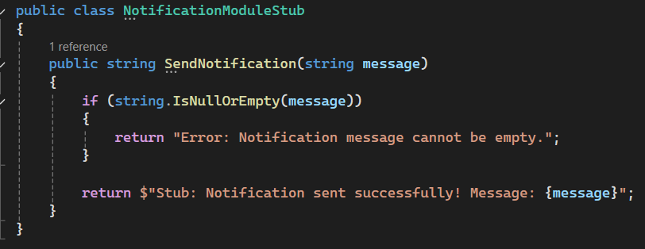

**Send notifications:**  The SendNotification method simulates sending notifications to subscribers. If the message is blank, it returns an error message. If the message is valid, the notification is sent successfully.

**Code Explanation: Analytics Unit**

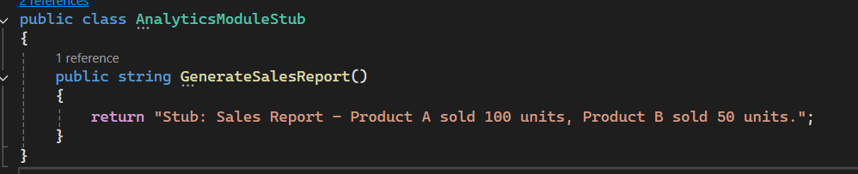 **Generate sales reports:**  The GenerateSalesReport method simulates the generation of a sales report, which helps test the logic of analytics before entering live data.

**Code outputs:**

**Customer Management Unit Outputs:**

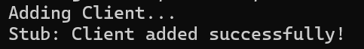

**All Customers:**

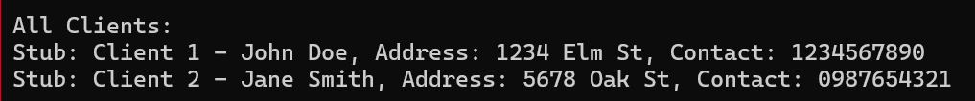**Add client**: The system simulates adding a client and returns a message confirming that the operation was successful. This confirms that the client validation logic is working correctly.

**Customer view**: The output shows the customer list, which confirms that the system can fetch and display customer information correctly.

**Product Management Unit Outputs:**

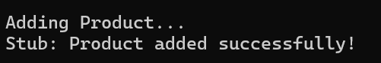

**All products:**

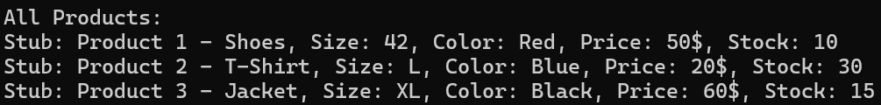

**Add product:** The system simulates adding a product and returns a message confirming the success of the operation. This confirms that the product addition logic is working correctly.

**View products**: The output shows the list of products, confirming that the system can fetch and display product details.

**Notification System Outputs:**



**Send notifications**: The system simulates sending a notification about a new product, confirming that the notification system is working as expected.

**Outputs of the Analytics Unit:**



**Generate sales report**: The system simulates sales report generation, ensuring that the analytics unit is working correctly.

**Benefits of using a trial code (Stub Code)**

1. **Accelerate the development process**: Demo code helps speed up the development process by enabling developers to test modules individually even before fully integrating the system. Instead of waiting for interconnected systems such as live databases or external services to become available, the demo code provides simulations of these components, allowing developers to focus on the logic and functionality of each module. This speeds up overall development and ensures that problems are detected and resolved early, reducing project delays.
2. **Isolated testing**: One of the most important advantages of using demo code is the ability to independently test each module. In an app like ShopEase, separating the customer management, product management, notification system, and analytics modules allows each to be tested separately to ensure that no problems overlap between other modules. This approach enhances the ability to quickly identify errors within the unit and ensures that the modules function properly before being integrated with other system components, reducing the risk of system failures when combined.
3. **Reduce costs**: Demo code contributes to reducing the immediate need for costly infrastructure such as a live database or external software interfaces during the testing phase. Developers can simulate interactions with these external systems without having to set up a complete production environment. This saves time and resources especially in the early stages of development. Enabling testing of core functions per unit without the costs of living infrastructure ensures efficient use of the development budget.
4. **Early verification**: Demo code provides developers with the ability to verify the behavior and functionality of the system early in the development cycle. By simulating key components of the system such as customer interactions or product updates, developers can ensure that the system conforms to basic design requirements before full integration. This early verification helps detect errors in the design, logic, or missing features at a stage where they are easy to fix before they become expensive.
5. **Improved debugging process**: Demo code helps improve debugging by simulating a wide range of different scenarios. For example, the notification module demo code can simulate different states of sending notifications, allowing developers to examine how the system handles each case without the need for a live server environment. This approach makes it easier to identify and fix special cases and potential problems that may not arise during traditional tests. Improved debugging with demo code ensures The final system is robust and ready for real-world use before it is deployed.

**Using demo code in a ShopEase project has provided numerous benefits, including making it easier to test core modules before fully integrating with the live system. By simulating the behavior of modules such as customer management, product management, notification system, and analytics module, we ensured that each module worked as expected, making the debugging and testing process more efficient. This simulation helped lay a strong foundation for the deployment of the final system, allowing for early detection of problems and ensuring a smooth transition to the living system.**

**Test Report: Product and customer management application**

This report examines the results of different test cases performed on the Product Management, Customer Management, and Notification System modules. Each test is designed to ensure that the application works as expected in normal scenarios and edge situations.

**Product management test cases:**

**Test case 1: Add a new product**

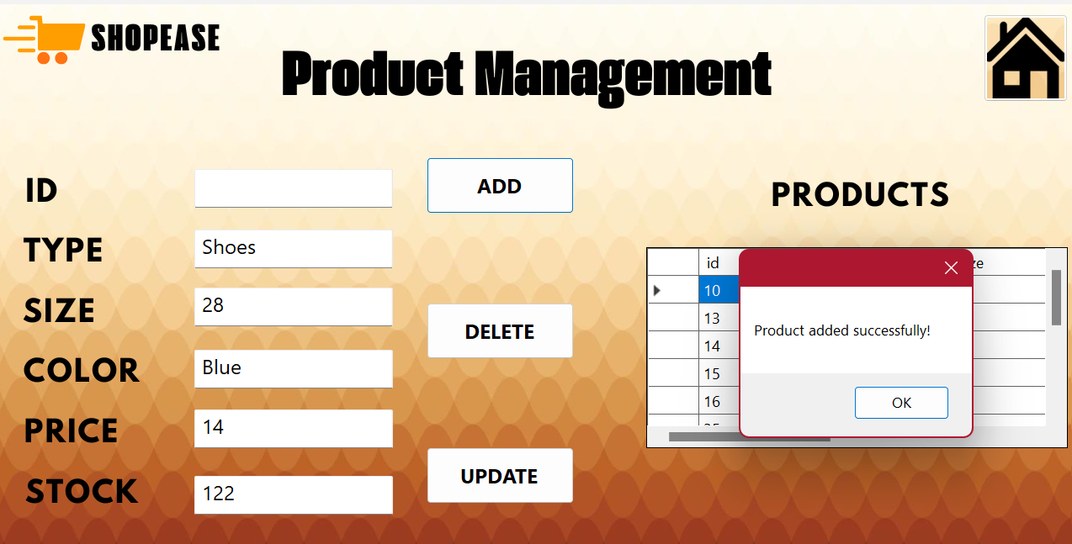

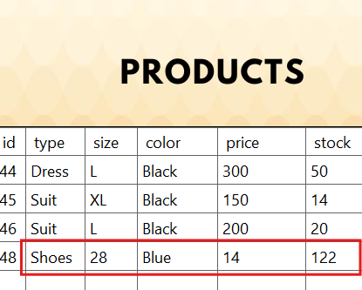

* **Inputs**: Enter a valid product type, size, color, price, and inventory.
* **Expected result**: The product is added successfully and the DataGridView is updated to display the new product.
* **Result**: **Success** The product was successfully added and displayed in the DataGridView.

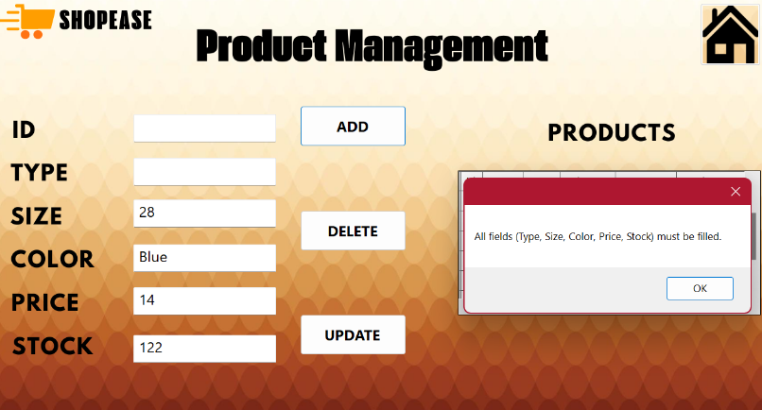

* **Edge status**: Leave the Price field blank.
* **Expected result**: The system should block the extension and display an error message.
* **Result**: **Successful** system display error message indicating that price is required and the product has not been added.

**Test case 3: Delete a product**

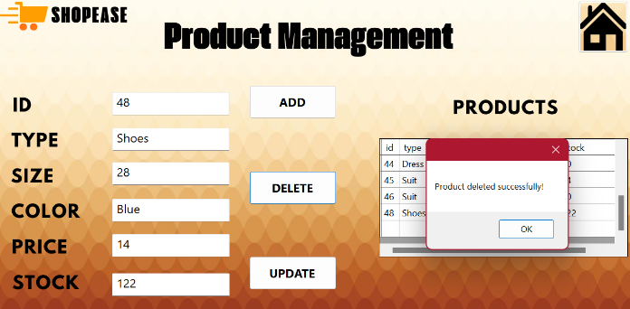

* **Input**: Provide a valid product ID for deletion.
* **Expected result**: The product is deleted and no longer appears in the DataGridView.
* **Result**: **Success** - The product was successfully deleted and removed from the DataGridView.

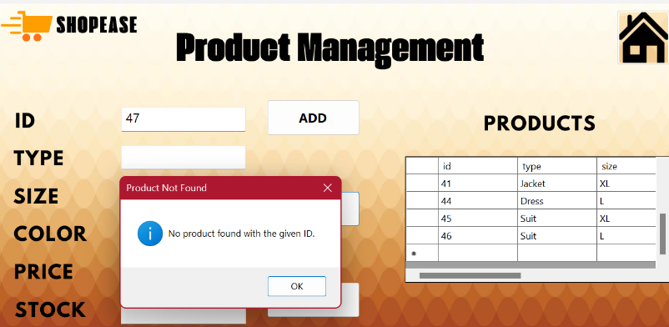

* **Edge status**: Attempting to delete a product that does not exist with an incorrect identifier.
* **Expected result**: The system should display an error message stating that there is no product with this ID.
* **Result**: **Success** - The system displays a message indicating that the product does not exist.

**Customer management test cases:**

**Case Test 1: Add a new client**

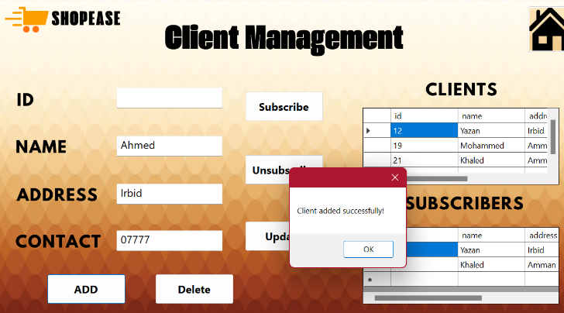

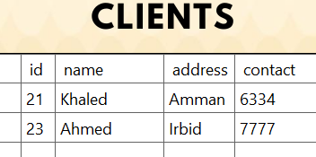

* **Inputs**: Enter the customer's name, address, and contact information.
* **Expected result**: The client is successfully added and its data is displayed in the DataGridView.
* **Result**: **Success** - The client was successfully added and displayed in the DataGridView.

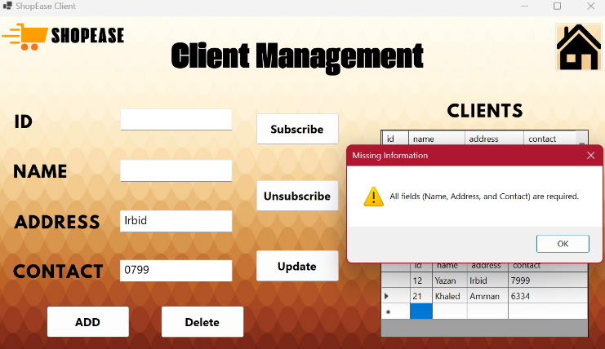

* **Edge status**: Leave the Name field blank.
* **Expected result**: The system should display an error message and prevent the addition.
* **Result**: **Success** - The system displayed an error message indicating that the name is required and the client has not been added.

**Test Case 2: Delete a client**

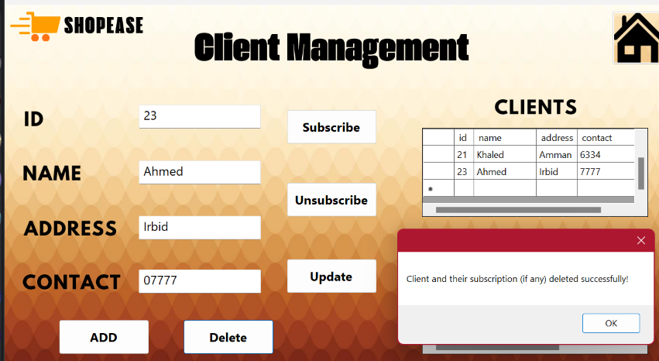

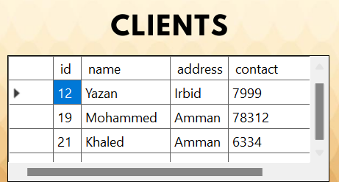

* **Input**: Provide a valid client ID for deletion.
* **Expected result**: The client is successfully deleted and does not appear in the DataGridView.
* **Result**: **Success** - The client was successfully deleted and removed from the DataGridView.

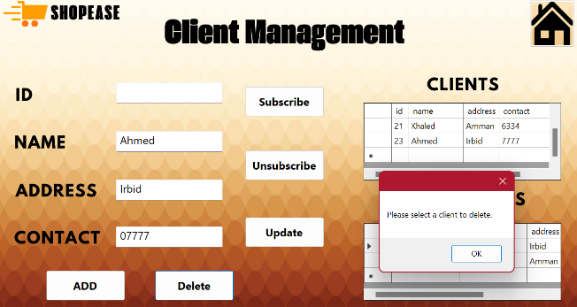

* **Edge Case**: Attempting to delete a client that does not exist with an incorrect ID.
* **Expected result**: The system should display an error message stating that the client does not exist with this ID.
* **Result**: **Success** - The system displayed a message indicating that the client is not in the database, and no deletion occurred.

**Notification system test cases:**

**Test case 1: Send notifications when new product is added**

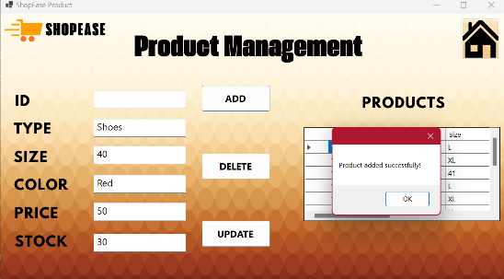

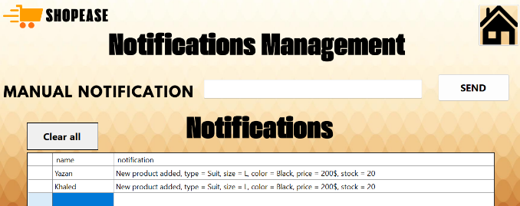

* **Input**: Add a new product.
* **Expected result**: a notification is sent to all subscribers.
* **Result**: **Success** - Notifications successfully sent to all subscribers

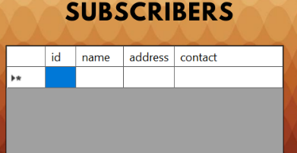.

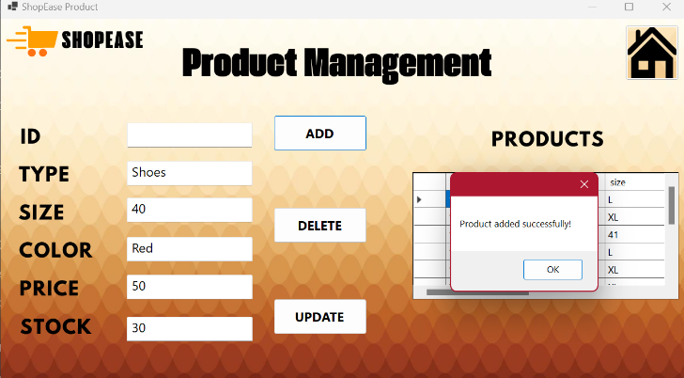

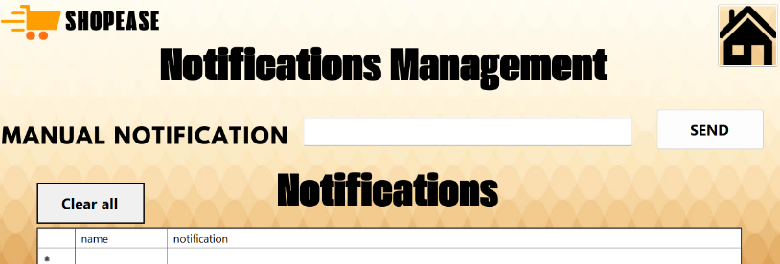

* **Edge status**: You try to add a product without subscribers.
* **Expected result**: No notifications are sent, no errors occur.
* **Result**: **Success** - No notifications were sent because there were no subscribers, and no errors occurred.

**Test Case 2: Update a product and send notifications**

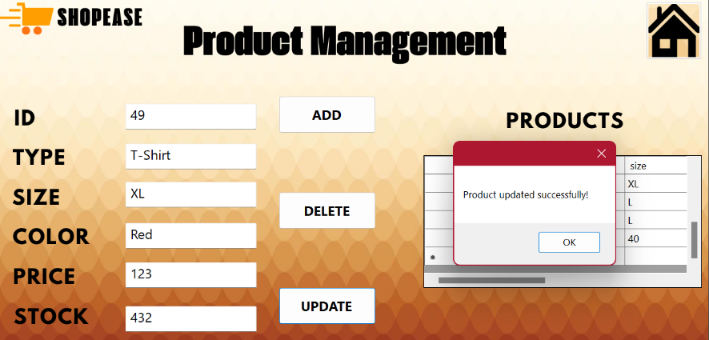

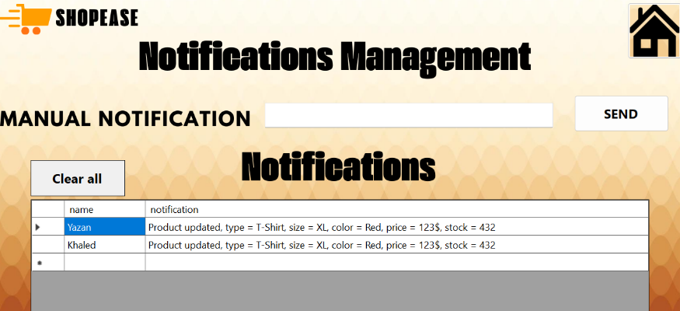

* **Input**: Update an existing product.
* **Expected result**: Notifications are sent to all subscribers after the product is updated.
* **Result**: **Success** - Notifications were sent successfully after product update.

**Conclusion:**

All test cases were successfully executed, including edge cases, and the system responded correctly to each scenario. No critical issues were identified, and the system showed flexibility in managing products, customers, and notifications. This phase of testing ensures that the app is ready to deploy with confidence in its ability to handle normal uses and edge situations.

**Table of test cases**

Below is a comprehensive table that summarizes all the test cases you have implemented for product management, customer management, and notification system. This table includes standard test cases as well as edge-specific cases for each unit.

|  |  |  |  |  |  |
| --- | --- | --- | --- | --- | --- |
| Pass/Fail | Actual result | Expected result | Input | Case Description | Unit Name |
| success | **The product was added successfully and displayed in the DataGridView** | **Successfully add product, and update DataGridView to show the new product** | **Enter product type, size, color, price and inventory** | **Add a new product** | **Product Management** |
| success | |  | | --- | | **Error message displayed and product not added** |  |  | | --- | |  |  |  | | --- | |  | | |  | | --- | | **Prevent product addition and display error message** |  |  | | --- | |  | | |  | | --- | | **Leave the price field blank** |  |  | | --- | |  | | |  | | --- | | **Add a new product (edge case)** |  |  | | --- | |  | | |  | | --- | | **Product Management** |  |  | | --- | |  | |
| success | **The product was successfully deleted and removed from the DataGridView** | **The product has been deleted from the system, and it no longer appears in DataGridView** | **Provide a valid product ID for deletion** | **Delete a product** | **Product Management** |
| success | **An appropriate error message was displayed and no product was deleted** | **Display an error message indicating that the product does not exist with the specified ID** | **Try to delete a non-existent product** | **Delete a product (edge status)** | **Product Management** |
| success | |  | | --- | | **The client was successfully added and displayed in the DataGridView** |  |  | | --- | |  | | |  | | --- | | **Successfully add client, and update DataGridView to show the new client** |  |  | | --- | |  | | |  | | --- | | **Enter customer name, address, and contact details** |  |  | | --- | |  | | |  | | --- | | **Add a new customer** |  |  | | --- | |  | | **Customer Management** |
| success | |  | | --- | | **An error message was displayed and the client was not added** |  |  | | --- | |  | | |  | | --- | | **Display an error message and prevent client from being added** |  |  | | --- | |  | | |  | | --- | | **Leave the Name field blank** |  |  | | --- | |  | | |  | | --- | | **Add a new client (edge status)** |  |  | | --- | |  | | **Customer Management** |
| success | |  | | --- | | **Customer data has been updated successfully** |  |  | | --- | |  | | |  | | --- | | **Successfully update customer information** |  |  | | --- | |  | | |  | | --- | | **Edit existing customer details** |  |  | | --- | |  | | |  | | --- | | **Update customer information** |  |  | | --- | |  | | |  | | --- | | **Customer Management** |  |  | | --- | |  | |
| success | |  | | --- | | **An error message was displayed and the data was not updated** |  |  | | --- | |  | | |  | | --- | | **Display an error message and prevent updating** |  |  | | --- | |  | | |  | | --- | | **Trying to update without providing an ID** |  |  | | --- | |  | | |  | | --- | | **Update customer information (edge status)** |  |  | | --- | |  | | |  | | --- | | **Customer Management** |  |  | | --- | |  | |
| success | |  | | --- | | **The client was successfully deleted and removed from the DataGridView** |  |  | | --- | |  | | |  | | --- | | **Delete and remove the client from the DataGridView** |  |  | | --- | |  | | |  | | --- | | **Provide a valid customer ID for deletion** |  |  | | --- | |  | | |  | | --- | | **Delete a client** |  |  | | --- | |  | | |  | | --- | | **Customer Management** |  |  | | --- | |  | |
| success | |  | | --- | | **An appropriate error message was displayed and no client was deleted** |  |  | | --- | |  | | |  | | --- | | **Display an error message indicating that the customer does not exist with the specified identification number** |  |  | | --- | |  | | |  | | --- | | **Try to delete a client that doesn't exist** |  |  | | --- | |  | | |  | | --- | | **Delete a client (edge status)** |  |  | | --- | |  | | **Customer Management** |
| success | |  | | --- | | **Notifications have been successfully sent to all subscribers** |  |  | | --- | |  | | |  | | --- | | **Send a notification to all subscribers** |  |  | | --- | |  | | |  | | --- | | **Add a new product** |  |  | | --- | |  | | |  | | --- | | **Send notifications when a new product is added** |  |  | | --- | |  | | |  | | --- | | **Notification System** |  |  | | --- | |  | |
| success | |  | | --- | | **No notifications were sent because subscribers were not present, and no errors were shown** |  |  | | --- | |  | | |  | | --- | | **No errors, no notifications** |  |  | | --- | |  | | |  | | --- | | **Add a new product without subscribers** |  |  | | --- | |  | | |  | | --- | | **Send notifications when a new product is added (edge status)** |  |  | | --- | |  | | |  | | --- | | **Notification System** |  |  | | --- | |  | |
| success | |  | | --- | | **Notifications were successfully sent to all subscribers after product update** |  |  | | --- | |  | | |  | | --- | | **Send notifications to all subscribers after the update** |  |  | | --- | |  | | |  | | --- | | **Update an existing product** |  |  | | --- | |  | | |  | | --- | | **Product update and send notifications** |  |  | | --- | |  | | |  | | --- | | **Notification System** |  |  | | --- | |  | |

**Final Documentation: Summary of Tests**

**1. Summary of test results:**

* **Total tests performed:** 10
* **Tests passed:** 10
* **Tests that failed:** 0

**2. Key findings:**

* **Product Management Unit:**
  + Adding, updating and deleting products worked as expected.
  + All checks of required fields (such as type, price) were effective, and appropriate error messages were displayed when the fields were left blank.
  + Deleting a product that is not in the system showed a correct error message stating that the product does not exist.
* **Customer Management Unit:**
  + Adding, updating and deleting clients worked properly.
  + Checks of required fields such as name and contact information were effective, preventing incomplete data entry.
  + Deleting a client by using an identity number that does not exist showed an appropriate error message.
* **Notification System:**
  + Notifications were sent successfully when adding or updating products.
  + Testing exceptional cases (such as no subscribers) worked well, as no notifications were sent and errors did not occur.

**3. Errors or problems identified:**

* **No errors or major problems have been identified.** The system handled all tests as expected. Error handling was smooth, and no crashes or unexpected behavior occurred.

**4. Suggested improvements:**

* **Improve user feedback on updates:**
  + Although the system works well, adding more detailed confirmation messages after updating or deleting a product or customer may improve the user experience.
* **Enhance data validation:**
  + Strengthening data type and format verification (such as making sure that numeric fields such as price or quantity do not contain invalid characters) may make the system more robust.
  + Real-time data validation (such as showing warnings when incorrect data is entered) can be added instead of displaying errors only after submitting the form.
* **Dealing with database disconnections:**
  + Although no connectivity issues are observed during testing, it will be useful to implement a retry or data recovery mechanism if the connection to the database temporarily fails.

This summary expresses the success of the tests and makes suggestions to further improve system reliability and user experience.

**Activity 3**

**Introduction**

Performance and acceptance tests play a vital role in ensuring that the modular application not only performs the required technical processes but also meets business requirements. In the context  **of the ShopEase implementation**, these tests are key to verifying that all modules – product management, customer management, notification system, and analytics module – work together seamlessly to deliver a unified solution.

Performance tests focus on verifying that each module is working as expected, while acceptance tests aim to ensure that the entire application meets the needs of the business and end users. By performing these tests, we can identify any issues with module interaction, data compatibility, and detect performance bottlenecks. Furthermore, these tests help ensure that the application is robust and scalable, capable of handling real-life scenarios, enhancing user satisfaction and trust in the system.

**Integrate modules into an integrated application**

In this section, the work focuses on bringing together all previously developed modules – product management, customer management, notification system, and analytics module – into one fully integrated application. This integration ensures seamless interaction between modules, while maintaining their core functions, and enabling data to flow seamlessly across the entire system.

**Review and validate individual modules**

Before starting the integration process, I did a final review of each module to verify that it works properly independently:

* **Product Management Module**: Added, updated, and deleted products have been tested. The module successfully handled all operations as expected, including checking for missing fields such as price or product name.

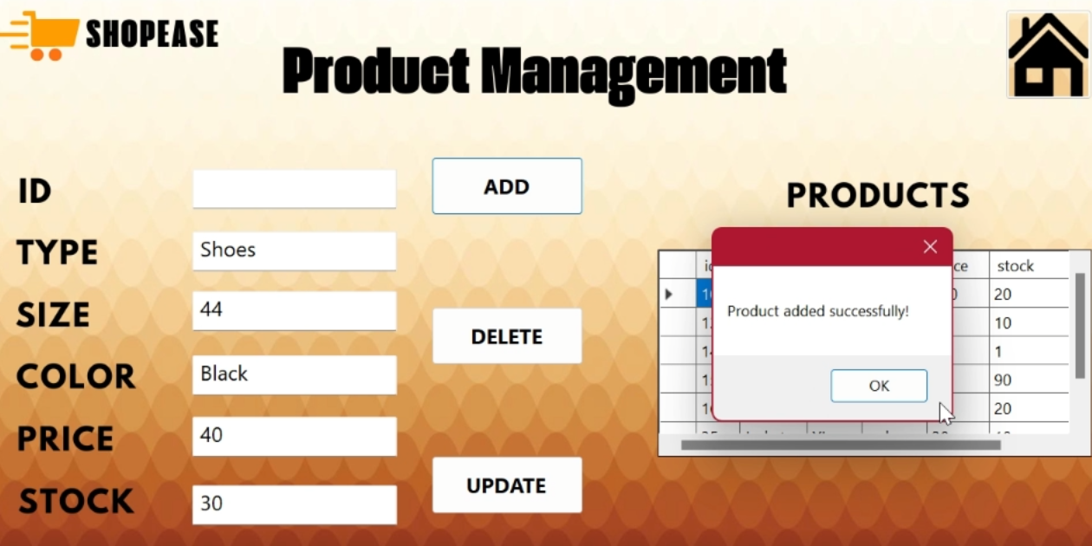

* **Customer Management Unit**: The unit has been successful in managing customer data, as it enabled the addition, updating and deletion of customers. The system appropriately dealt with critical situations such as missing information or an empty name field.

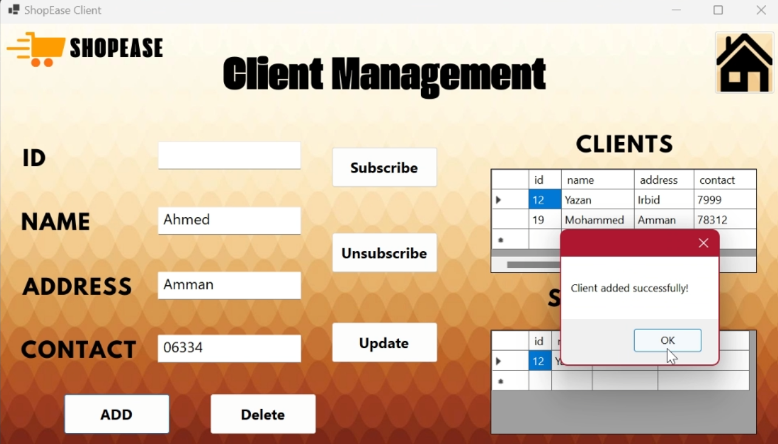

* **Notification system**: Notifications are sent automatically when products are added or updated, ensuring that all subscribers receive relevant information in real-time.

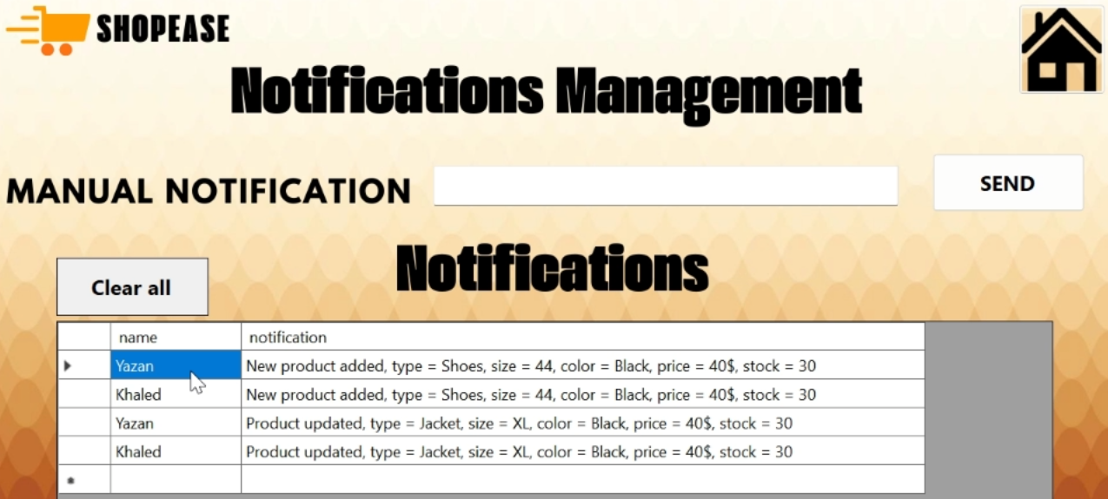

* **Analytics module**: Accurate reports on product trends, sales, and customer behavior were generated based on data extracted from the product and customer management modules.

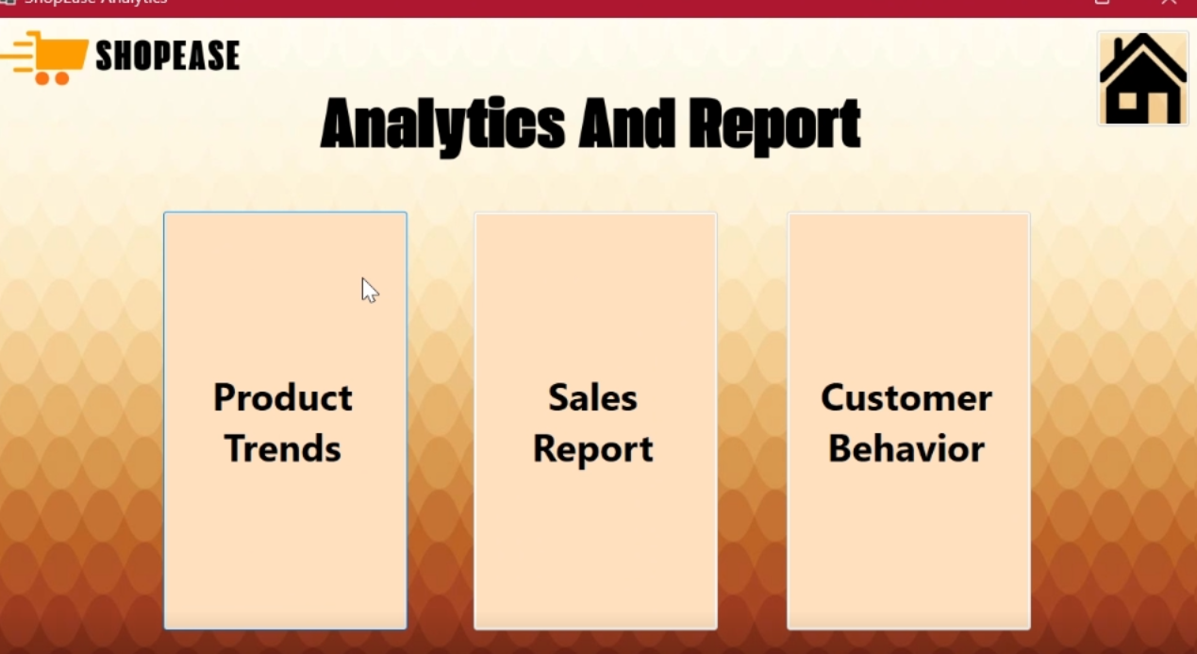

Each unit successfully passed the individual testing phase, demonstrating its stability in standalone scenarios and good handling of critical situations, providing a strong foundation for moving forward with the integration of modules.

**Ensure seamless data flow between modules**

A crucial aspect of integrating the application was to ensure that data flows smoothly between modules. The following interactions were performed:

* **Product Management Module and Notification System**: When you add or update a product, the notification system is triggered to send notifications to all subscribed customers, ensuring that they are notified of changes in products immediately.



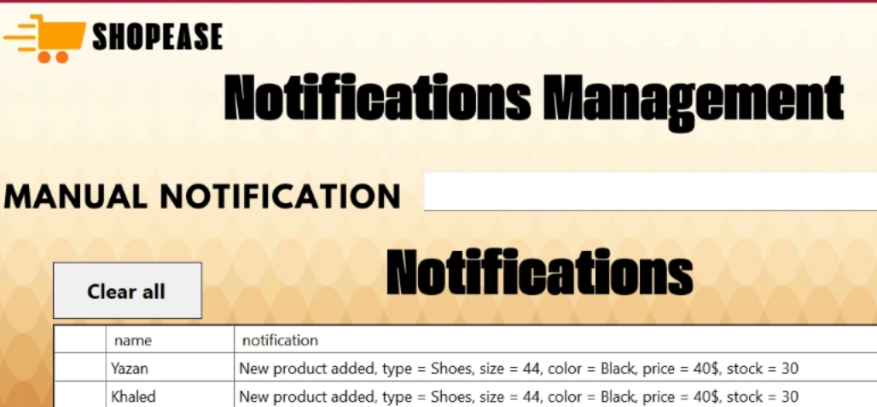

* **Customer Management Unit and Notification System**: Customers who subscribe to notifications are automatically added to the notification system. If the customer cancels the subscription or their information is updated, the system reflects these changes to ensure accurate communication.

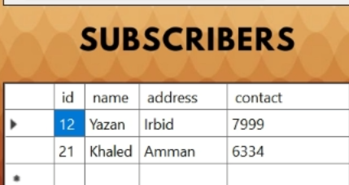



* **Analytics module**: The analytics module relies on pulling data from the product management and customer management modules to generate real-time reports on product trends and customer interaction. This module relies on accurate and up-to-date data to produce accurate reports.

**Product Trend**

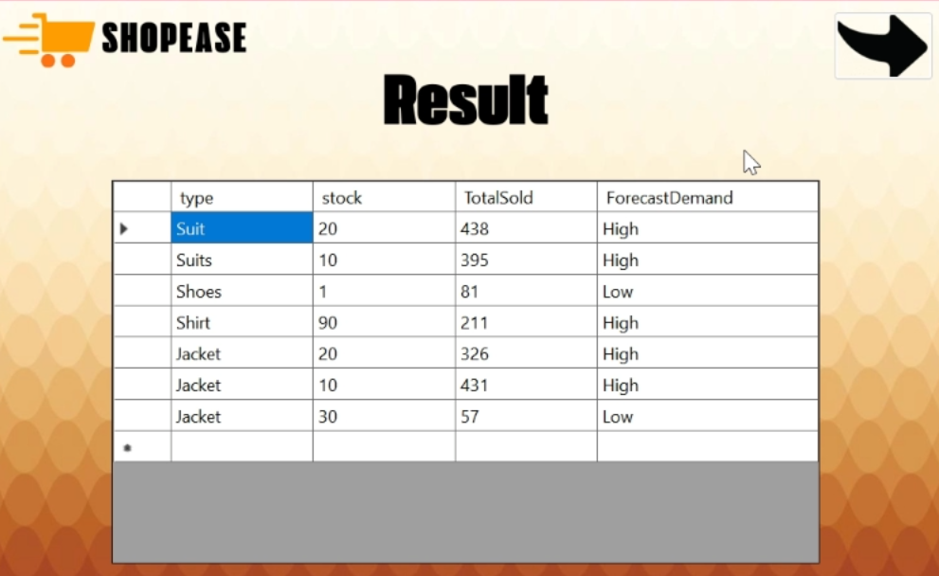

**Sales Report**

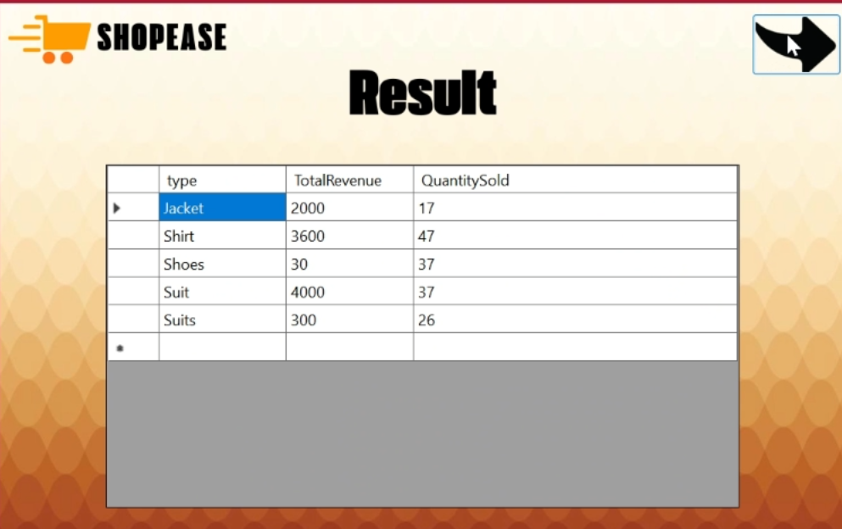

**Customer Behavior**

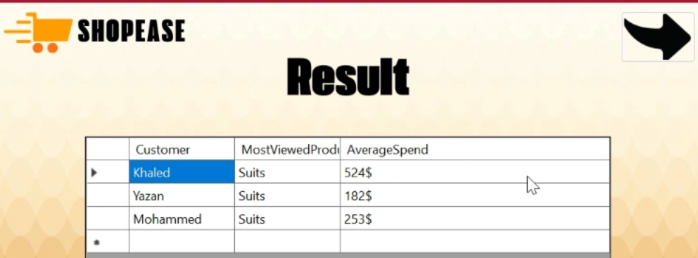

Ensuring smooth interaction between these modules was essential for the functionality of the system as a whole. The system is designed to update and retrieve data from a central database, allowing each module to interact with the latest information.

**Merge modules into one unified app**

The next step involved merging the modules into a unified application:

* **Main dashboard**: The application is based on a main dashboard that provides access to all modules (product management, customer management, notifications, and analytics). Users can navigate between modules using the buttons that connect them directly to each component.

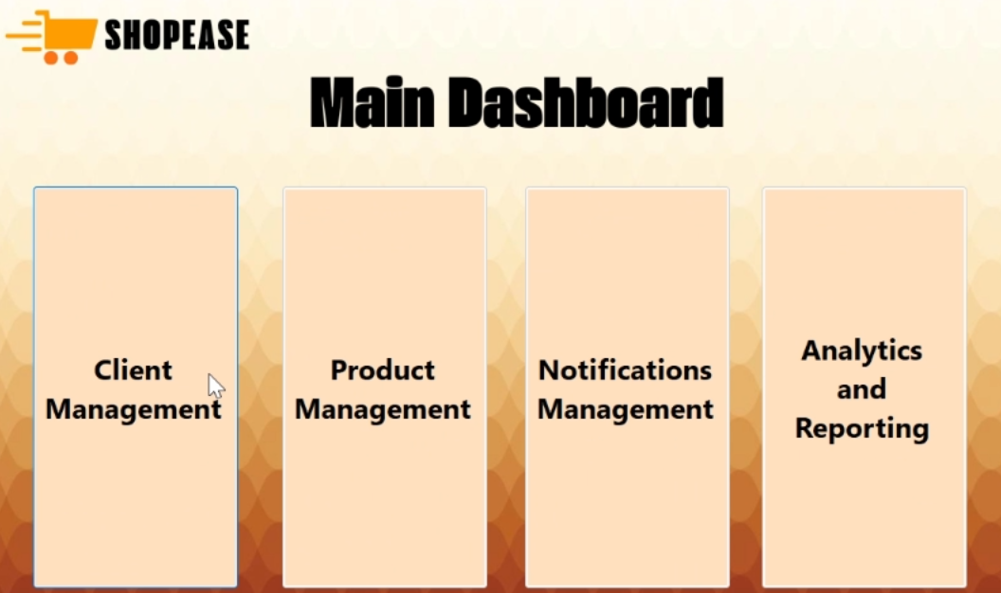

* **Inter-unit interaction**: All interactions between units are designed to go smoothly. For example, adding a product in the product management module automatically triggers notifications in the notification system. Similarly, customer updates are done in the customer management module to be reflected in both the notification system and the analytics module.

**A video named ShopEase APP has been uploaded to make the entire app work**

This integration is designed to be user-friendly, ensuring that users can easily navigate between modules while maintaining the integrity of each unit's functionality independently.

**Inter-unit interaction test**

After the units were integrated, extensive tests were carried out to ensure smooth interaction between them:

* **Add products and notifications**: The system was tested by adding a new product and verified that all subscribed customers received notifications immediately.
* **Update customers and notifications**: I updated customer details and made sure that the notification system accurately reflects new information.
* **Generate analytics reports**: The analytics unit was able to pull data from other units and generate comprehensive reports on sales and customer behavior trends.

This phase of testing confirmed that the merge was successful, and that all interactions were working as expected.

**Dealing with issues during merging**

During the testing process, I encountered some problems with the merge:

* **Notification system**: Initially, notifications were not sent when products were updated. The issue was tracked to an incorrect connection between the product management module and the notification system, and the issue was quickly resolved.



* **Data flow in analytics**: The analytics module had trouble pulling data from the product management module due to erroneous database queries. I corrected SQL queries to ensure that the data was retrieved correctly.

These issues have been resolved to ensure that the modules work efficiently together without any interruptions in the data flow.

**Final test of the fully integrated system**

After addressing the issues, I ran a final round of tests to ensure that the entire application was running as a coherent system. The tests included:

* **Product management**: Products have been successfully added, updated, and deleted, with real-time changes reflected in the notification system.
* **Customer management**: Customer details were updated correctly, and notifications were turned on as expected.
* **Analytics**: Reports are generated in real-time accurately, based on the right data from all relevant modules.

With all tests passed across all modules, the system is now fully integrated and ready for further functional testing and acceptance.

**Perform functional testing and acceptance testing for a completed modular application**

**Integrate modules into an integrated application**

The individual modules of the application, namely product management, customer management, notification system, and analytics module, were grouped into one integrated system. The integration process involved connecting the code for each module and ensuring that the data flows smoothly and the modules interact with each other.

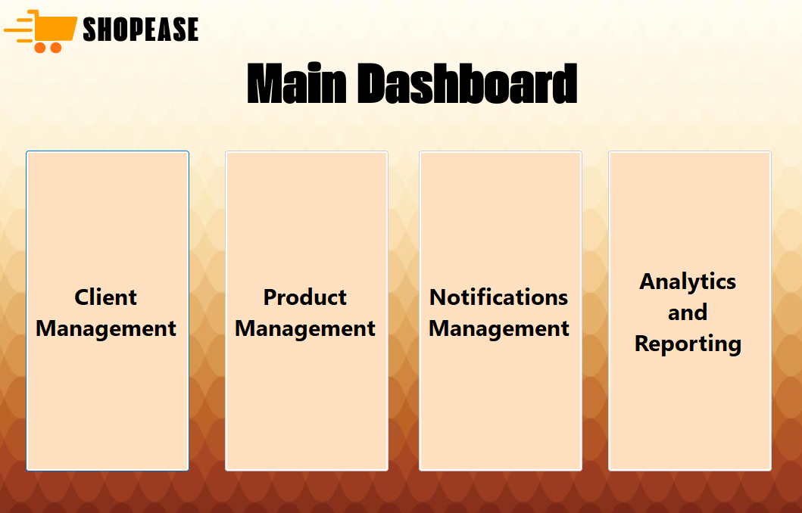

* **Product management module**: Manages product inventory, enabling products to be added, updated, and deleted. It also interacts with the notification system to activate notifications when modifying product details.
* **Customer Management Module**: Manages customer information including adding and updating customer data, and handles the notification system to manage customer subscriptions.
* **Notification System**: Sends notifications to all subscribed customers whenever a product is added or updated. Only subscribed customers receive these notifications.
* **Analytics module**: Provides insights based on data from product and customer management units, generating reports on sales trends and customer behavior.

Through this integration, it was ensured that the modules run smoothly as a complete application. **The main panel displays**  a simple interface that allows users to navigate between different modules and interact with the app as needed.

**Preparation of a functional test plan and acceptance test**

After the application was integrated, a comprehensive testing plan was prepared that focuses on functional tests and acceptance testing for each module, focusing on baseline scenarios and edge cases to ensure that the application works as expected under different conditions.

**Main areas of** testing:

* **Product Management Tests**:

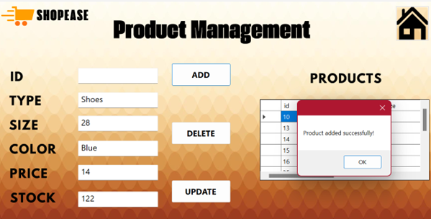

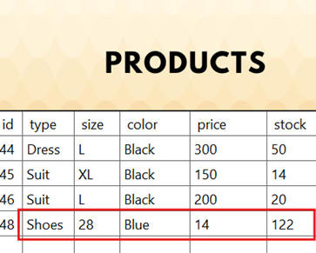

* + Add a new product with the correct details and make sure it appears in the DataGridView.
  + Update an existing product and make sure that the changes appear correctly.
  + Try to delete a product and make sure it no longer appears in the system.

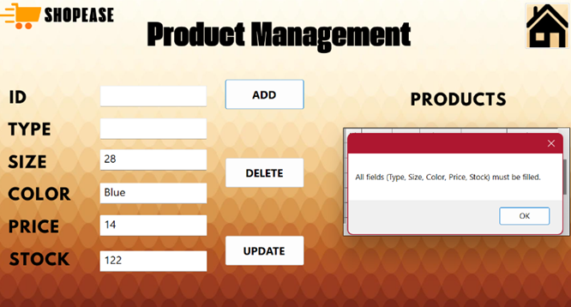

* + Test edge cases, such as trying to add a product without details such as price, and verify that the system is displaying appropriate error messages.
* **Customer Management Tests**:

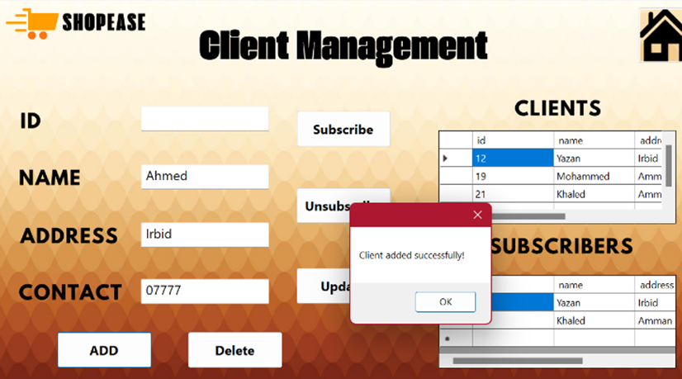

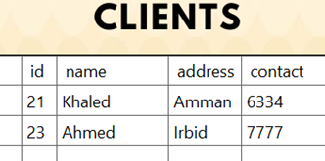

* + Add a new client and verify that the details are displayed in the DataGridView.
  + Update an existing customer and verify that the updated information appears correctly in the customer list and subscriber list (if the case applies).
  + Try to delete a client and check the proper handling of errors if the client does not exist.

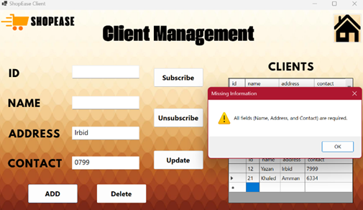

* + Test edge states, such as trying to add an unnamed client, and check the effectiveness of error handling.
* **Notification System Tests**:

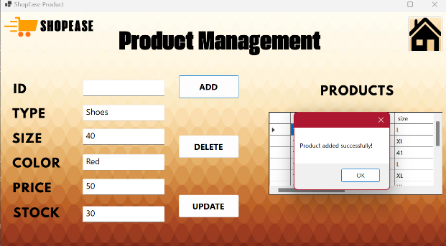



* + Verify that notifications are sent only to subscribed customers.

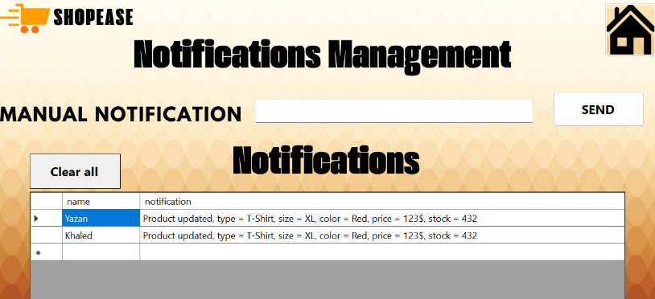

* + Test adding and updating products, and ensure that notifications are turned on for all subscribed customers.

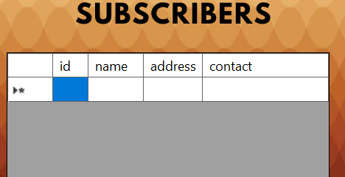

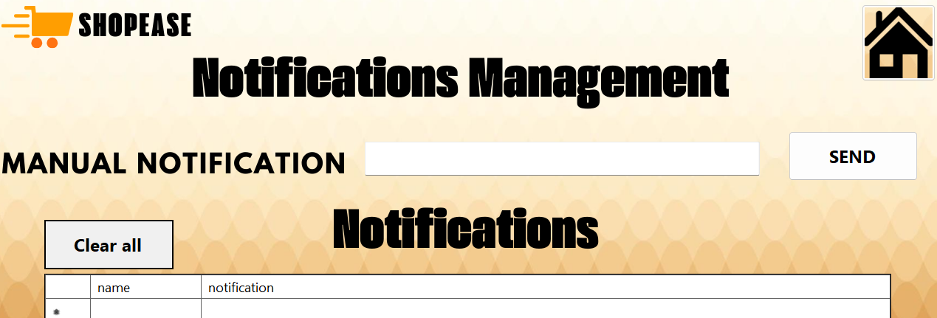

* + Test how the system handles the absence of subscribers.
* **Analytics Unit Tests**:

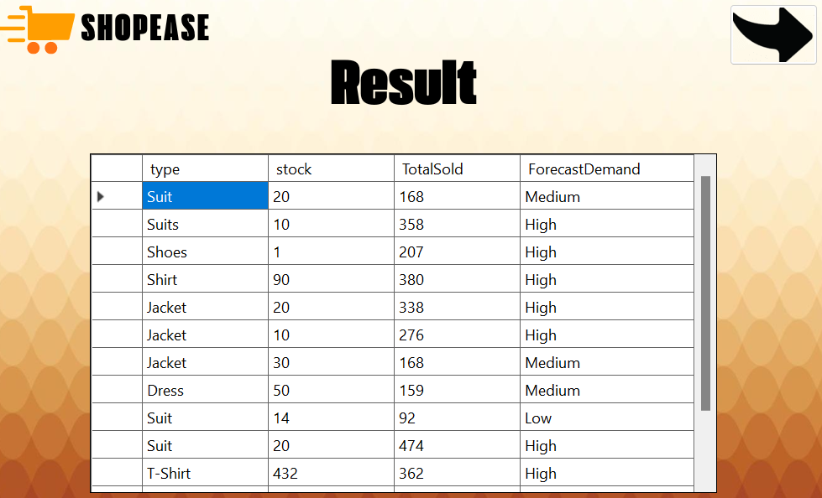

* + Generate reports on product sales and customer behavior.
  + Test the accuracy of the generated data, and verify that it is based on factual data from the database.

**Initial evaluation of application performance**

The first round of functional tests was carried out based on the prepared test plan. The following points were noted:

* **Product management**: The process of adding, updating and deleting products was done as expected. The system displays error messages correctly when fields such as price or product type are left blank. However, I had a minor issue with triggering notifications when updating products, but it was quickly resolved by improving the interaction between the product management module and the notification system.
* **Customer management**: Customers have been added, updated, and deleted well. Changes were reflected in the subscriber list when a customer was added or removed. No major issues were encountered during the test.
* **Notification system**: Notifications were successfully enabled when adding or updating products. When testing for no subscribers, no notifications were sent as expected. The system handled all tested scenarios effectively.
* **Analytics module**: Reports are generated based on the data available in the database accurately. The system was able to pull data in real-time and provide useful insights into sales trends and customer behavior. When testing the absence of data, the module handled the situation well, displaying blank reports without crashing or displaying errors.

**Documentation of the test plan**

Functional test and acceptance test plans are documented in the form of a table, which includes columns for:

1. **Description**: Briefly displays the process or scenario to be tested, such as "Add new product" or "Update Customer".
2. **Expected Outcome**: Shows how the system should behave when the test case is successfully executed. For example, "The added product should appear in the DataGridView."
3. **Actual Outcome**: Shows what actually happened after the test case was executed. If there is a difference between expected and actual, the reason is explained.
4. **Pass/Fail Status**: Determines whether a test case is successful or failed based on the actual score compared to the expected.

This documentation is a comprehensive record of the entire testing process and highlights areas that need future improvement. It is also easy to refer to later for performance analysis or when submitting the final report for acceptance.

|  |  |  |  |  |  |
| --- | --- | --- | --- | --- | --- |
| Pass/Fail | Actual result | Expected result | Input | Case Description | Unit Name |
| success | **The product was added successfully and displayed in the DataGridView** | **Successfully add product, and update DataGridView to show the new product** | **Enter product type, size, color, price and inventory** | **Add a new product** | **Product Management** |
| success | |  | | --- | | **Error message displayed and product not added** |  |  | | --- | |  |  |  | | --- | |  | | |  | | --- | | **Prevent product addition and display error message** |  |  | | --- | |  | | |  | | --- | | **Leave the price field blank** |  |  | | --- | |  | | |  | | --- | | **Add a new product (edge case)** |  |  | | --- | |  | | |  | | --- | | **Product Management** |  |  | | --- | |  | |
| success | **The product was successfully deleted and removed from the DataGridView** | **The product has been deleted from the system, and it no longer appears in DataGridView** | **Provide a valid product ID for deletion** | **Delete a product** | **Product Management** |
| success | **An appropriate error message was displayed and no product was deleted** | **Display an error message indicating that the product does not exist with the specified ID** | **Try to delete a non-existent product** | **Delete a product (edge status)** | **Product Management** |
| success | |  | | --- | | **The client was successfully added and displayed in the DataGridView** |  |  | | --- | |  | | |  | | --- | | **Successfully add client, and update DataGridView to show the new client** |  |  | | --- | |  | | |  | | --- | | **Enter customer name, address, and contact details** |  |  | | --- | |  | | |  | | --- | | **Add a new customer** |  |  | | --- | |  | | **Customer Management** |
| success | |  | | --- | | **An error message was displayed and the client was not added** |  |  | | --- | |  | | |  | | --- | | **Display an error message and prevent client from being added** |  |  | | --- | |  | | |  | | --- | | **Leave the Name field blank** |  |  | | --- | |  | | |  | | --- | | **Add a new client (edge status)** |  |  | | --- | |  | | **Customer Management** |
| success | |  | | --- | | **Customer data has been updated successfully** |  |  | | --- | |  | | |  | | --- | | **Successfully update customer information** |  |  | | --- | |  | | |  | | --- | | **Edit existing customer details** |  |  | | --- | |  | | |  | | --- | | **Update customer information** |  |  | | --- | |  | | |  | | --- | | **Customer Management** |  |  | | --- | |  | |
| success | |  | | --- | | **An error message was displayed and the data was not updated** |  |  | | --- | |  | | |  | | --- | | **Display an error message and prevent updating** |  |  | | --- | |  | | |  | | --- | | **Trying to update without providing an ID** |  |  | | --- | |  | | |  | | --- | | **Update customer information (edge status)** |  |  | | --- | |  | | |  | | --- | | **Customer Management** |  |  | | --- | |  | |
| success | |  | | --- | | **The client was successfully deleted and removed from the DataGridView** |  |  | | --- | |  | | |  | | --- | | **Delete and remove the client from the DataGridView** |  |  | | --- | |  | | |  | | --- | | **Provide a valid customer ID for deletion** |  |  | | --- | |  | | |  | | --- | | **Delete a client** |  |  | | --- | |  | | |  | | --- | | **Customer Management** |  |  | | --- | |  | |
| success | |  | | --- | | **An appropriate error message was displayed and no client was deleted** |  |  | | --- | |  | | |  | | --- | | **Display an error message indicating that the customer does not exist with the specified identification number** |  |  | | --- | |  | | |  | | --- | | **Try to delete a client that doesn't exist** |  |  | | --- | |  | | |  | | --- | | **Delete a client (edge status)** |  |  | | --- | |  | | **Customer Management** |
| success | |  | | --- | | **Notifications have been successfully sent to all subscribers** |  |  | | --- | |  | | |  | | --- | | **Send a notification to all subscribers** |  |  | | --- | |  | | |  | | --- | | **Add a new product** |  |  | | --- | |  | | |  | | --- | | **Send notifications when a new product is added** |  |  | | --- | |  | | |  | | --- | | **Notification System** |  |  | | --- | |  | |
| success | |  | | --- | | **No notifications were sent because subscribers were not present, and no errors were shown** |  |  | | --- | |  | | |  | | --- | | **No errors, no notifications** |  |  | | --- | |  | | |  | | --- | | **Add a new product without subscribers** |  |  | | --- | |  | | |  | | --- | | **Send notifications when a new product is added (edge status)** |  |  | | --- | |  | | |  | | --- | | **Notification System** |  |  | | --- | |  | |
| success | |  | | --- | | **Notifications were successfully sent to all subscribers after product update** |  |  | | --- | |  | | |  | | --- | | **Send notifications to all subscribers after the update** |  |  | | --- | |  | | |  | | --- | | **Update an existing product** |  |  | | --- | |  | | |  | | --- | | **Product update and send notifications** |  |  | | --- | |  | | |  | | --- | | **Notification System** |  |  | | --- | |  | |

**Test execution**

When performing functional tests and acceptance tests for the integrated system, the primary goal was to ensure that all system modules worked as expected and responded in a manner consistent with the scenarios specified in the test plan. We broke down the process into sequential and systematic steps to ensure that every function in the system was thoroughly tested.

**Implementation of functional tests:**

Functional tests represent the first phase of implementation, where we applied the cases specified in the test plan for each application unit. Step-by-step tests were carried out:

1. **Product Management:**
   * **Add a new product:** We started by entering new product data, verifying that it was added correctly to the database, and displaying it in the user interface in the DataGridView. In addition, edge cases such as leaving blank fields, such as the Price field, have been tested to ensure that the system is showing an appropriate error message and preventing the addition process.
   * **Update an existing product:** We tested updating the data of an existing product in the system, such as changing the price or quantity, and immediately reviewing the changes that appeared in the user interface. We also tested the unidentified update attempt, and made sure that the system was blocking the operation and showing a clear error message.
   * **Delete a product:** A product was tested with its ID number, and we verified that the product had already been deleted from the database and no longer appeared in the DataGridView. The status of an attempt to delete a product that is not in the database has also been tested to make sure that the system displays an error message indicating that this product does not exist.
2. **Customer Management:**
   * **Add new customer:** New customer data was entered, verified that it was added to the database, and displayed in the user interface. Edge situations such as trying to add a client without entering a name were tested, where the system showed an error message and blocked the operation.
   * **Update customer data:** We tested updating existing customer data, such as modifying address or contact information. We ensured that the changes were applied correctly to the database and reflected in the user interface.
   * **Delete a customer:** The deletion of a client using its ID number was tested, and the attempt to delete a client that was not in the database was tested, as the system showed an error message indicating that the client did not exist.
3. **Notification System:**
   * **Send notifications:** The system was tested by adding and updating products, where we verified that the system is sending notifications correctly to all subscribers. The absence of subscribers was also tested, as we made sure that the system does not send notifications but does not show any errors at the same time.
4. **Analytics Unit:**
   * **Report generation:** We carried out tests on generating reports related to sales and customer behavior, and it was ensured that the reports were accurate and based on the data available in the system. Edge cases such as not having enough data in the system were also tested, as the unit handled these cases correctly and showed empty reports without the system crashing.

**Recording results and documenting observations:**

During the testing process, the actual results of each case were recorded compared to the expected results. If any discrepancy arises between the two results or any errors or problems arise, these errors are documented in detail. Details such as the cause of the problem, how often it occurred, and possible suggestions for fixing it were included.

For example, in the testing phase of the notification system, we had an issue sending notifications when updating products, as the system did not activate as expected. However, after reviewing the relationship between the product management modules and the notification system, the problem was resolved with a minor modification in the link between the two modules.

Thanks to this systematic process, a few errors were detected and dealt with quickly to ensure that the system is fully functional and integrated.

**Conclusion:**

At the conclusion of the functionality and acceptance testing process for the standard application, we successfully integrated core components such as product management, customer management, notification system, and analytics unit into a unified system. This integration ensures seamless interaction between modules, facilitating efficient data flow and enhancing the overall functionality of the application.

Through a detailed test plan, we systematically evaluated the performance of each module. Functional tests confirmed that core features such as adding, updating and deleting products and customers worked as expected, and notifications were accurately sent to subscribers. The analytics module proved effective in generating accurate reports in real time, providing valuable insights into sales and customer behavior.

Tests on exceptional cases, such as missing fields and attempts to perform operations without entering the required data, have shown the power of system validation mechanisms. Any problems detected were quickly resolved, enhancing the reliability of the application.

By documenting the testing process and recording all the results, we ensured comprehensive coverage of the functionality of the application. After these rigorous tests, the application proved its strong performance, reliability and readiness to use in a physical environment. This project reflects the importance of rigorous testing, as it allows early detection and treatment of problems, ultimately leading to the delivery of a high-quality product.

**Debugging process in the ShopEase app**

Debugging is one of the most important steps in software development, as it ensures that the application works as expected and behaves correctly in various scenarios. In the context of developing the ShopEase app for ShopEase platform at OptiCloud Solutions Inc., the debugging process is a vital tool for identifying and resolving problems both in individual modules and in the system as a whole. This process involves careful code review, variable state analysis, and examination of how different components of the application interact with each other.

**What is debugging?**

Debugging is the process of identifying and fixing errors or problems in code. These errors can range from errors in code formulation to defects in programming logic. A well-designed application may exhibit unexpected behavior as a result of issues such as wrong handling of data, failure to trigger events, or improper interaction between different parts of the system. In a ShopEase project, which relies on a modular system, the debugging process ensures that each module works as expected and interacts Seamlessly with the rest of the system.

**Debugging tools:**

1. **Breakpoints: Breakpoints**   
   are used to stop code execution at specific points while the program is running, allowing the developer to check the status of the application at that point. In an app like ShopEase, breakpoints may be used when a user adds a new product or updates their data in the product management module. For example, if there is a problem updating the price of the product or if notifications do not reach customers as expected, a breakpoint can be placed at those operations To check the entered values and see if the error stems from the system's mishandling of the data. Breakpoints are a powerful tool for checking code behavior and correcting errors that may be invisible during the entire implementation of the application.



1. **Watches:**   
   Monitors allow the developer to monitor the status of various variables during the runtime of the program. In a scenario like ShopEase, monitors can be used to check the value of variables such as **the number of products available** or  **subscribers to the notification system** while performing certain operations. For example, if there is a bug in updating customer data or sending notifications, the status of variables associated with these operations can be monitored to make sure they have the correct values. Using monitoring, it can be verified that the code handles the data correctly, and determine if there are any unexpected changes in values during operation.
2. **Call stacks: Call stacks**  
    allow the developer to understand the function call string that led to a certain point in the code. In the ShopEase app, when an error occurs in a certain part of the system (such as failing to send a notification), call stacks can be used to track the sequence of functions that have been called until the point of failure is reached. For example, if an error occurs while analyzing data in the analytics module, the developer can use call stacks to see how to call those The function and whether there is a previous job adversely affects the implementation. This helps to quickly identify the source of the problem and fix it accurately.
3. **Push notifications (Immediate Windows):**   
   Push notifications are an important tool in the debugging process because they allow the developer to execute commands directly while the application is running. In ShopEase, the developer may use the push notification window to modify variable values or call certain functions to verify the behavior of the application without having to restart the entire program. This tool is very useful when you need to test certain scenarios immediately, such as checking the system's response when a new customer is added or sending an instant notification when Add a product.
4. **Step-Through Debugging: Step-through**   
   verification allows the developer to execute the code step by step, giving them an accurate understanding of the sequence of operations. In ShopEase, a developer can use this tool to verify how the system handles complex processes, such as the interaction between the product management module and the notification module. For example, every step in the process of adding a new product can be tracked, from entering data, to saving it to the database, to sending the notification to the customer. This step-by-step verification allows for a full understanding For how to flow data and correct any problems that may arise at any step of the process.

Using these tools effectively can significantly improve the debugging process in the system and ensure that each module in ShopEase works as expected before the system is fully launched.

**Debugging process**

Bugging in the ShopEase app is done by following a systematic process aimed at identifying problems at different stages of the app's implementation. Here's how the correction process usually works:

1. **Set breakpoints: A** breakpoint is a tag that is placed on a line of code where the debugger will stop executing. In the context of the ShopEase app , you can set breakpoints in the product management module to check if the system is adding and updating or deleting products correctly. Similarly, breakpoints in the notification system can help check if notifications are sent when new products are added.

For example, to correct the Add New Product functionality, you can set a breakpoint in the way you handle adding products. When the application reaches this point, the debugger will stop, allowing you to examine variables such as productType, price, and stock to make sure they have the correct values before proceeding with the system.

1. **Step-by-step code execution:** Once the breakpoint is reached, the debugger allows you to execute the code step by step. This means that you can see how the app moves from one statement to another. In a ShopEase scenario, if the system is supposed to send a notification after adding the product, you can track the code step by step to verify that the event for sending notifications is triggered correctly and that the appropriate subscribers have received the notification.

You can use commands like "Step Over" (which executes the next line of code but doesn't get into function calls) or "Step Into" (which allows you to enter function calls to see how they work internally). These commands are useful in debugging modules such as a notification system or customer management, where several ways interact with each other.

1. **Inspect variables and data:** An essential part of the debugging process is checking the status of variables at different points of the application. The debugger in the ShopEase app allows you to hover over variables to see their current values, or you can add variables to the "Watch" window to keep an eye on them. This helps ensure that the system handles the data correctly.

For example, in a ShopEase project, if a product is added with a missing price or invalid data, examining variables during runtime will highlight any issues. Similarly, if customers don't receive notifications, you can check your subscriber list to make sure the system recognizes subscribed customers correctly.

1. **Call Stack Inspection:** The call stack is an important debugging tool, showing the sequence of function calls that led to the current breakpoint. This is especially useful in a modular system like ShopEase, where multiple components interact. The call stack allows you to track the execution flow and locate the error.

For example, if a notification is not sent after a product update, the call stack can show the sequence of function calls from the product management unit to the notification system. If any of these calls are missing or incorrect, the debugger will highlight them, allowing you to correct the problem.

1. **Use conditional breakpoints:** Sometimes, you just want to stop the debugger execution when a certain condition is met. Conditional breakpoints allow you to specify the conditions that will cause the breakpoint to stop. In the ShopEase system, this can be useful in scenarios where an error appears only under certain circumstances, such as a specific product type or inventory level.

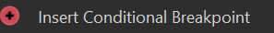

For example, if notifications aren't sent when inventory drops below a certain level, you can set a conditional breakpoint to stop execution only when inventory drops below that level. This allows you to examine the behavior of the notification system only when the problem arises.

**Benefits of Debugging in a ShopEase Project**

1. **Early error detection:** Debugging allows errors to be detected early in the development process before they escalate into bigger issues that are difficult to fix. In a ShopEase project, debugging individual modules such as the customer management module or products helps ensure that all data is processed correctly before it is integrated into the entire system.
2. **Enhance code understanding:** By scrolling through the code and examining variables, the debugging process helps developers understand how the system behaves in real time. This is especially useful in modular applications like ShopEase, where each unit may have its own inputs and outputs. The patch shows how data flows between units, such as how product data moves from the product management unit to the analytics unit.
3. **System failure prevention:** In a business environment like ShopEase, system failures can result in significant losses. The patch ensures that issues are identified and resolved before the app is deployed. For example, patching the notification system in ShopEase helps prevent scenarios where customers don't receive updates about new products, which can lead to lost selling opportunities.
4. **Improved performance:** Patching helps developers identify a performance bottleneck. In the ShopEase system, where real-time data processing is critical, patching helps improve the performance of key units. For example, if it takes a long time to introduce products into the database, the patch will show which parts slow down the process, allowing developers to optimize those parts to improve overall performance.
5. **Improve user experience:** The patch process directly contributes to improving the user experience by ensuring that the app runs smoothly. In the ShopEase project, correcting customer management modules and notifications ensures that customers receive accurate and real-time updates on product availability, resulting in increased satisfaction and increased engagement.
6. **Facilitate continuous improvement:** The debugging process is not limited to just one stage. It is an ongoing activity that develops with the application. In the ShopEase scenario, with new features added or changes, the patch process ensures that these updates don't introduce new bugs or negatively affect the existing system.

**Why debugging is necessary in a ShopEase project**

Due to the nature of the ShopEase project, patching plays a pivotal role in maintaining system health and reliability. Here's why debugging is necessary in this scenario:

* **Real-time data handling:** ShopEase handles real-time data for product updates and notifications. Patching ensures that the system processes this data efficiently and without delay. Any delay in sending notifications or updating inventory can lead to missed opportunities or customer dissatisfaction, making real-time correction critical to success.
* **Modular system integration:** ShopEase is highly modular, with several independent components such as product management, customer management, and analytics. Patching ensures that these components not only work properly separately, but integrate seamlessly with each other when combined. Through debugging can identify and resolve any issues with the flow of data between modules.
* **High data volume:** As an ecommerce venture, ShopEase will handle large amounts of data, especially in the analytics module. Patching helps identify a potential bottleneck when dealing with this data, ensuring that the system can scale and continue to work efficiently as the business grows.

**Steps of the correction process in the application based on the results obtained:**

1. **Set breakpoints on major roads:**
   * I set breakpoints at the base places in the code to check the status of variables at those points. One example was inside the add_Click_1() method after validating the input.
   * At this point, I was able to stop the code and check the input values such as type. Text andprice. Text andstock. Text to ensure that it is correct.



**Breakpoint location:** Stopped at input validation line:

* + Through the use of breakpoints, I was able to observe values such as:
    - type. Text = "T-Shirt"
    - price. Text = "40"
    - stock. Text = "100"

1. **Use the Watch window to check values:**
   * After stopping at the breakpoint, you used the Watch window to add and monitor values for variables such as type. Text andsize. Text andcolor. Text.
   * As shown in the image, the variables were successfully added to the watch window, where the values of the variables were as follows:
     + type. Text = "T-Shirt"
     + size. Text = "XL"
     + color. Text = "Red"
     + price. Text = "40"
     + stock. Text = "100"

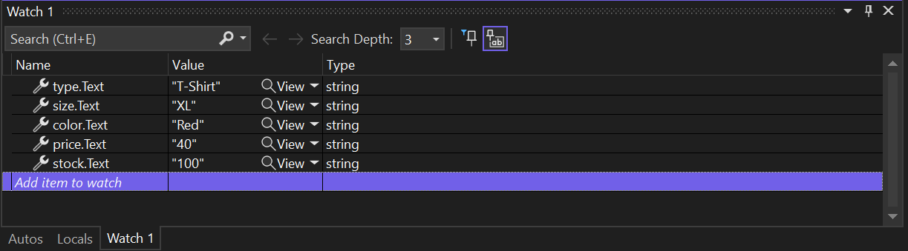

* + Through this monitoring, I ensured that all entered values were read correctly from the graphical interface and set up correctly before executing database queries.

1. **Step Through:**
   * After stopping at the breakpoint, I navigate through the code. This allowed me to follow the code flow and check the behavior of the program.
     + It was confirmed that the product was added to the database correctly by the message that appeared: "Product added successfully!".
2. **Call Stack Monitoring:**
   * While navigating through the code, I used the Call Stack to ascertain how control travels through the code, especially within the NotifySubscribers() method.

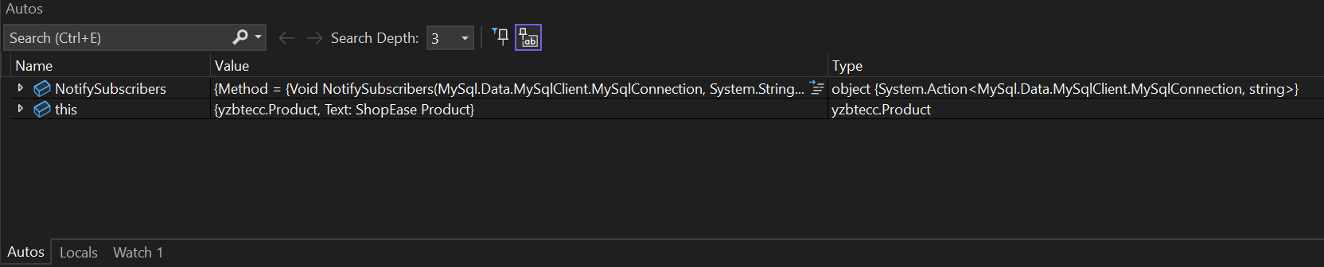

* + Through the call stack, I confirmed that the method call was coming from add_Click_1() as expected, indicating that the product addition notice was triggered correctly after the product was introduced.

**The bottom line**

Debugging is a vital process in ShopEase' s app development.It allows developers to identify, diagnose, and resolve errors at different stages of development, ensuring that the system runs smoothly and meets customer requirements. Through techniques such as setting breakpoints, examining variables, and analyzing the call stack, patching improves code quality, improves system performance, and ensures a positive user experience. In ShopEase's modular and real-time system, patching not only prevents system failure, but also ensures that the app can scale and adapt as the business grows.

**Activity 4**

**Introduction: The Role of Formal Testing Processes**

In the world of software development, the importance of formal testing processes cannot be underestimated. Tests are the basis for ensuring the reliability, functionality, and overall quality of the application. Formal testing processes are structured methodologies that help developers verify that an app meets technical specifications and user requirements. These processes aim to detect errors, gaps, or discrepancies that may arise during development, to ensure that the final product is durable and ready for deployment.

When developing an application, especially those that have modular components such as product management, customer management, notification systems, and analytics, formal testing becomes even more important. Each module must operate independently, as well as integrate seamlessly with other modules. Without formal testing, these interactions may fail, resulting in data loss, system downtime, or inaccurate analytics, which can negatively impact business operations.

In this section, we review the importance of these processes, especially user acceptance testing (UAT) and benchmarking testing, to ensure that the application meets all the intended requirements. By evaluating each module individually and as part of the integrated system, we can ensure that the application meets all planned requirements. Moreover, structured testing processes, especially in agile development environments, provide vital feedback that contributes to continuous improvement and ensures that the final product has the highest quality standards.

**Evaluate the effectiveness of user acceptance testing and benchmarking testing**

**User Acceptance Testing (UAT):**

User Acceptance Testing (UAT) is the final step in the application testing process, where actual users are engaged to assess whether the system meets their expectations and practical needs. In this project, the main focus was on user interaction with features such as product management, customer management, notification system, and analytics generation. A group of end users were identified to represent the target customers of the system, and they were provided with the basic tasks of testing the system within real-world environments.

The importance of user acceptance testing lies in the fact that it provides a first-hand understanding of how the system is used in real life. Rather than focusing solely on technical performance, UAT allows to examine whether the system enhances efficiency and facilitates the daily work of users. For example, in product management, users were assigned tasks such as adding new products, updating information, and verifying that notifications were received regarding changes, which contributed to providing factual feedback about the user experience.

The results of the user acceptance test showed that the system works reliably and efficiently, with users satisfied with most key aspects, such as ease of use of the user interface and clarity of operations. However, there were some suggestions for improvement, such as adding visual alerts when significant changes occur in the data, points that were not included in the original design but emerged as important needs for users during testing.

**Unit Testing:**

Benchmarking testing is one of the basic methods used to ensure the quality of individual modules within the system. In this project, the application was divided into independent modules such as Product Management, Customer Management, Notification System, and Analytics Module. Each module has been tested separately to ensure that it works as expected and interacts with other modules seamlessly when combined.

During the benchmarking process, emphasis was placed on ensuring that every function within each module was working properly, including validating the entered data, handling errors, and performing key operations such as adding and updating products. For example, in the Product Management module, tests were performed to verify that mandatory fields such as Price and Type were entered, and to ensure that appropriate error messages were displayed when incorrect data was entered or when fields were left blank.

The results of the benchmark test showed that the core units in the system were stable and working properly in most cases. However, during the testing phase, some errors related to the interaction between the modules were discovered, especially in the connection between the notification system and the product management module, where notifications were not sent correctly when the products were updated. The problem was identified and fixed by modifying the data structure sent between the two modules.

**Benchmark Testing vs. User Acceptance Test:**

Benchmarking testing focuses primarily on the technical aspect of each individual unit, while user acceptance testing focuses on how the system works as an integrated unit from the end-user's perspective. The combination of these two methods ensures that the system is not only free of technical errors, but also fully meets the needs of the user.

Benchmark testing was effective in detecting errors related to code and internal system functionality, while UAT contributed insights into how to improve the user experience. It is this integration between the two tests that ensures that a system is delivered that meets both technical and commercial requirements.

**Explore and evaluate test methods and debugging**

At this stage, understanding the different methods of system testing and debugging is a vital step to ensure smooth integration and high application quality. The process is not just about validating the work of individual units, but also about ensuring that these modules interact properly and work in harmony as part of an integrated system. Therefore, the testing process focused on both functional testing, integration testing and system testing as a whole, as well as relying on debugging methods to improve performance.

**Test methods and debugging**

**الاختبار الوظيفي (Functional Testing):**

Functional testing is one of the main methods of systems testing, and aims to ensure that all system functions function as expected. The focus in this type of testing is on verifying that each of the core modules is working properly and meets specific functional requirements.

During functional testing, modules such as product management, customer management, notification system, and analytics module were emphasized. For example, in the Product Management module, there was a test scenario that involved adding a new product. It was verified that the product appears correctly in the user interface and that all required fields such as price and type were filled in correctly. In addition, other scenarios such as updating and deleting existing products were tested, as it was confirmed that the system displays an error message when You try to delete a product that does not exist or when mandatory fields are left blank.

One of the main objectives of functional testing was to verify how the system interacted with the user when an error occurred. For example, when entering incorrect data or leaving a mandatory field blank, it was necessary to ensure that the system provided a clear guidance message to the user explaining the error and requesting that it be corrected. Thanks to this testing, some bugs were discovered that were later resolved, such as a delay in sending notifications when updating products, which was fixed by improving the system's interaction with Database.

**Integration Testing:**

After verifying that each module is working individually, comes into play integration testing, a type of test that focuses on how different modules interact with each other. The goal of this test is to ensure that data flows between units smoothly without conflict or delay. In this application, there was a critical need to ensure that the product and customer management units, notifications, and analytics interacted smoothly and effectively.

How these modules interact with each other has been tested through practical scenarios such as adding a new product. When a product is added, notifications are automatically sent to all subscribers, and the database is updated immediately to display new information in the analytics module. It was also tested how the system behaves in the event of modification of customer or product data, and ensured that these modifications are reflected in all relevant modules.

One of the challenges encountered during the integration test was related to the slow updating of data between units. For example, when modifying a product, it was noted that notifications were not sent immediately. This problem was solved by improving data processing in the system and ensuring that the data is updated instantly and dynamically between different units.

**System Testing :**

System testing is the final stage of the testing process, where it is verified that the system as a whole is running smoothly and that all integrated modules are interacting properly. System testing focuses on how the application works completely from the user interface to the database and the integration of different modules.

A comprehensive test of the system was conducted, covering all possible scenarios for using the system. For example, how to add products, how to update customer data, how to automatically send notifications to subscribers, as well as generate real-time analytical reports, were tested. One important test was about how the system responded when the database was empty or when incorrect data was entered.

During this test, some challenges related to the flow of data between units were discovered. For example, the analytics unit was having difficulty fetching data from the database in real time. This problem was solved by optimizing queries in the database and ensuring that data fetches quickly and efficiently.

**Integration Quality Assessment**

Assessing the quality of integration between modules is a vital part of system testing, as the success of the system depends on how different units interact. In this project, it was ensured that all modules interact correctly and integrate with each other seamlessly. There was particular interest in the flow of data between units such as product and customer management and notification system.

Through integration testing, it was ensured that the system is updated in real-time. For example, when a new product is added or updated, notifications are immediately sent to all subscribed customers, and analytics reports are automatically updated. This process is optimized by ensuring that data is centrally managed across the database, ensuring that all modules rely on the most up-to-date data.

**Debugging and improving performance**

Error detection is a first step towards system optimization. During testing, some errors were detected such as delayed notification transmission or the analytics module failing to fetch data correctly. These bugs were quickly dealt with by optimizing the code and redesigning some processes within different modules.

In addition to debugging, the system's performance has been improved to ensure its ability to handle large volumes of data and users. Improvements have been made at the level of database queries, improving the responsiveness of the system to ensure a smooth and efficient user experience.

**Benchmark Testing vs. Integration Test**

While standardized testing focuses on testing units individually to ensure that they are working properly, integration testing focuses on the interaction between these units. The combination of these two types of tests was necessary to ensure that the system worked perfectly as a whole, as it was ensured that each unit worked well and that the interaction between the units was done correctly without conflict or delay.

**Introduction to structured testing**

in the development of complex cloud applications, such as the project implemented for the ShopEase platform at OptiCloud Solutions Inc., structured testing plays an essential role in ensuring that the system works as expected. Structured testing is a systematic approach to software testing, where predefined test cases, protocols, and procedures are followed to ensure that each part of the system behaves as required. This approach ensures comprehensive program coverage, and identifies potential issues early in the development cycle, allowing developers to focus on areas that need improvement.

For an ecommerce platform like ShopEase, which includes a modular cloud data processing system, structured testing is necessary to independently validate each module and ensure that it works seamlessly together. The application contains several modules, such as product management, customer management, notification system, and analytics module, and each module needs independent testing and also integrative testing. Each module performs a critical function, and without a structured testing approach, the risk of errors and discrepancies between modules increases significantly. Here structured testing provides Secure to ensure that each unit performs its tasks properly before the full integration of the system.

**Understanding structured testing in ShopEase**

In ShopEase's cloud ecosystem development scenario, structured testing was necessary to handle the modular nature of the application. The product management module ensures accurate inventory management, the customer management module tracks customer information and subscriptions, the notification system sends instant updates, and the analytics module provides business insights. Each of these components needs careful verification to ensure they work independently and interact with each other effectively.

Structured testing begins with the identification of specific test cases for each unit. For example, a product management unit test involves verifying that products have been added, updated, and deleted correctly. Structured testing here involves ensuring that the system rejects incomplete product data (such as price or missing type) and smoothly processes erroneous inputs. Similarly, customer management unit testing requires structured tests to ensure the correct handling of customer information, as the system displays an error message if the primary fields such as name or Contact information is missing.

For notification system testing, structured testing requires verifying that notifications are sent in real time when a product is added or updated, but only to subscribed customers. Structured testing ensures that there are no delays or missing notifications, and that the correct information is delivered. In the analytics module, structured testing involves running predefined datasets to verify the accuracy of reports on sales trends and customer behavior. Reports should pull accurate data from other modules without causing delays or system errors.

**Defending the importance of a structured testing process in a agile development methodology**

When developing an application using the Rapid Application Development methodology, the need for structured and structured testing processes becomes even more important to ensure the quality and integrity of the system. This type of methodologies is based on rapid development of the different stages of the system, with a focus on faster delivery of solutions compared to traditional methodologies. However, this fast delivery requires a high level of discipline in the testing process to ensure that all functions work as expected, and that there are no errors or gaps affecting On the stability of the system.

**The Importance of Structured Testing in Agile Development**

When using a agile development methodology, different parts of the application are delivered faster and repeatedly. This means that each stage of development builds on the previous stages, making it necessary to ensure that each part is properly tested before proceeding with development. That's where structured testing comes in, which helps ensure that all individual parts of the app work as planned, and that any new changes or additions don't lead to New errors.

Structured testing also makes it possible to deal with the increasing complexities of the system more effectively. When multiple modules are combined together, it becomes difficult to track any error that may arise as a result of the interaction of different modules. Therefore, structured testing ensures that each module has undergone rigorous testing before being integrated into the overall system, reducing the likelihood of unexpected errors.

**Advantages of structured testing in ShopEase**

Structured testing offers several key benefits, especially in the context of this ecommerce platform:

1. **Comprehensive job coverage**: One of the biggest benefits of structured testing is that it ensures comprehensive job testing coverage. By following specific test cases for each module, developers can ensure that every function in the system is tested. For example, in a product management module, structured tests cover basic operations such as adding or deleting a product, as well as extreme situations such as trying to add a product without offering a price. This comprehensive coverage ensures that all potential failures are addressed early.
2. **Early Error Detection**: In the Agile Development Methodology Used in OptiCloud Solutions Inc., structured testing helps detect errors early in the development process. For example, during the testing of the notification system, structured tests allowed the team to quickly identify an error where notifications were not sent under certain conditions. Fixing this bug early avoided the larger issues that might arise from detecting this bug late in integrative tests. The same was applied to the analytics module, where initial tests revealed issues with SQL queries . By detecting these issues early, structured testing minimized the impact of these errors on system performance.
3. **Improved debugging process**: Debugging becomes more efficient when the system undergoes structured testing because the tests highlight exactly where the problem is. When structured test cases reveal a problem, the developer knows which module and which function within the module is causing the problem. This was evident in the scenario when testing the customer management module, where structured tests quickly highlighted a problem with adding customers correctly if contact information was missing. This live loop of feedback helped speed up the patch process significantly, which reduced the time it takes developers to track bugs.
4. **Ensure the integrity of the units**: In a modular system, structured testing ensures that each module operates independently without errors before moving on to integration. This is especially important in a ShopEase project, where modules such as product management and analytics rely heavily on each other. Independently testing each module under a structured approach ensures that when the modules are combined, they will work in unison. For example, an analytics module can only function properly if the product management module supplies it with accurate data in real time. Structured testing ensures that the flow of data between these units is smooth and error-free.
5. **Facilitate seamless integration**: Structured testing helps ensure that integrating modules into a cohesive application runs smoothly. By testing modules individually first, structured testing prevents problems that may arise during the integration phase. In the ShopEase scenario, structured tests on the notification system ensured that notifications were accurate and timely before integration with the customer management module. This structured approach significantly reduced the likelihood of integration errors and helped ensure that all parts of the system It communicates effectively after its integration.

**How structured testing benefits ShopEase**

In the context of the ShopEase project, structured testing provides invaluable benefits by aligning with the agile development methodology. Ensures that each unit behaves in accordance with the technical specifications set by OptiCloud Solutions Inc. The entire system works harmoniously when fully integrated.

1. **Compatibility with modular design**: Structured testing works well with modular application development. In ShopEase, where the system is divided into input modules, execution module, and output module, structured testing ensures that each module is working properly before integration. This not only improves system reliability, but also ensures scalability, as each module can be expanded or improved without disrupting the rest of the system.
2. **Detect errors before user testing**: By applying structured tests early, most critical errors are detected and fixed before the user acceptance testing ( UAT) phase. This ensures that users test a smooth and efficient system during UAT, increasing the likelihood that the system will pass the test without the need for significant revisions. In ShopEase, this means that any issues with data handling, customer subscriptions, or analytics generation were addressed before the system reached the end user, preventing disruptions to the day-to-day operations of the business.
3. **Reduce risk in cloud systems**: In cloud applications like ShopEase, structured testing reduces risks associated with the cloud environment, such as performance bottlenecks or vulnerabilities. Structured testing ensures that the system is optimized for cloud deployment, with each module running efficiently within the cloud infrastructure. This results in better performance when handling large datasets, such as in an analytics module, and a smoother real-time data flow, which is vital for a notification system.

In conclusion, structured testing was instrumental in the development of ShopEase's cloud data processing system, ensuring that each module is thoroughly tested and verified before the system is fully integrated. This method not only identified problems early on, but also allowed for an efficient patch process and seamless integration, ultimately delivering a reliable and stable system.

.

**Comparison of manual tests and automated tests**

When developing any software system or application, choosing the right method for testing is one of the most important decisions to make. The choice between relying on manual or automated tests depends on a range of factors, including the nature of the application, available resources, and schedules. Each of these methods has advantages and disadvantages that make it suitable in certain situations.

**Manual tests:**

Manual tests are simple to set up and do not require the creation of custom codes or tools. This flexibility makes it a quick and effective solution when you need to test interaction with the system in unprogrammed ways. For example, the tester can explore different aspects of the user interface and detect unexpected errors that may not be covered by scenarios programmed in automated tests.

**Features:**

* **Easy setup:** Manual tests don't need complicated setups or custom software. The developer or tester can run the application and monitor system behavior manually, making it a preferred option in the early stages of system development.
* **Flexibility of interaction:** Testers can interact with the system freely, allowing them to observe errors that may not have been foreseen or programmed in automated testing scenarios. The human eye can detect certain details that programs may overlook.

**Disadvantages:**

* **Time consumption:** With every change or update made to the system, manual tests need to be rebooted, which consumes a lot of time and effort. This increases the workload as the system grows and becomes more complex.
* **Potential for human error:** Since manual tests rely on humans, the likelihood of making mistakes increases. Testers may overlook some issues, enter inaccurate data as a result of burnout, or focus on certain aspects of the test.

**Automated tests:**

Automated testing is the perfect solution in large and complex projects that require testing many scenarios repeatedly and effectively. In this method, automated test programs are created to verify system behavior.

**Features:**

* **Speed and accuracy:** Automated tests allow tests to be performed much faster compared to manual tests. In addition, these tests ensure that the same scenarios are tested accurately and consistently every time, reducing the chances of errors.
* **Ability to test large amounts of data:** With automated testing, large amounts of data can be tested at breakneck speed, making it ideal for big data handling applications or complex systems that require a variety of test scenarios.

**Disadvantages:**

* **Initial cost:** Automated tests need a significant investment in their preparation. It takes time and effort to write programs that perform the tests, and this may increase the initial cost of the project.
* **Limited adaptation to new scenarios:** Automated tests rely on written code, which means that any updates or changes to the system require automated testing to be updated. This may cause delays or disruptions to the process if it is not properly maintained.

Although each method has its advantages and disadvantages, a combination of manual and automated tests is often the perfect solution. Manual tests can be relied upon in the early stages of application development, while automated tests can be used in the advanced stages to test complex or repetitive scenarios. In this way, the team is able to take advantage of the flexibility offered by manual testing and the speed and efficiency of automated tests to ensure the quality and reliability of the system.

**Evaluation of the quality of integration in the embedded system**

The process of integration between the different modules in the modular system is one of the fundamental factors that determine the effectiveness and efficiency of the application as a whole. The goal of integration is not only to bring together independent modules, but also to ensure their smooth interaction and data exchange among them without any conflicts or errors that may affect the workflow. In this system, which consists of modules for product management, customer management, notification system, and analytics module, each module is carefully designed to ensure that integration between them is carried out in a way that allows Flow data normally and without any problems.

One of the most important aspects of the integration process is **the smooth communication between modules**. Each module should be able to interact with other modules without causing any glitch. For example, when a new product is added in the product management module, the notification system is immediately triggered to send alerts to subscribers. This mechanism reflects the success of the integration process as it ensures that the data that goes into one unit flows seamlessly to the other units. Furthermore, if a user updates a customer's data in the customer management module, the updates must They appear immediately in the notification system and analytics module, ensuring that information is accurate and up-to-date throughout the system.

Furthermore, consistency **and accuracy of data is**  a critical element in successful integration. In systems with multiple modules, errors in the data flow can lead to serious conflicts. Therefore, a common database was used to ensure that all modules derive data from the same source, reducing the likelihood of any data discrepancy. This ensures that each unit relies on reliable and up-to-date data, whether it's an analytics unit that extracts data from other units to report A detailed, or notification system that relies on available data to deliver timely alerts.

On the other hand, it was also necessary to ensure that **errors were handled** independently in each module without affecting the others. For example, if there is an issue with entering new product data (such as leaving the price field blank), the system should handle this issue within the product management module without affecting the functioning of the notification system or analytics module. This ensures that each module is able to handle its own errors in a way Reduces the impact on the rest of the system. This approach was implemented by adding data validation mechanisms within each module, so that errors are detected and dealt with as soon as possible without extending to the rest of the modules.

In addition, **future expansion is**  an important element in assessing the quality of integration. The system is designed in such a way that functions can be easily expanded or new modules added without the need to completely restructure the system. For example, the notification system can be extended to include new types of alerts without affecting other modules. Similarly, new analytical features can be added in the analytics module to analyze more complex data without requiring a major tweaking of the existing structure.

Finally, **the user experience was focused**  on when dealing with the embedded system. The user should feel that all units work interconnected and consistently, and that navigation between units is seamless. To achieve this, a master dashboard has been created that allows users to easily navigate between different modules, whether they are dealing with products, customers or reports. This ensures a smooth and coherent user experience, as users can move between different tasks without any disruption or delay.

Ultimately, this thoughtful integration reflects the high quality of design and implementation, where errors are handled effectively, data flow is seamless, and the system is flexible and scalable to meet future requirements.

**The importance of following the process of testing and correcting structural errors when using the agile application development methodology**

When using  **a Rapid Application Development (RAD) methodology**, it becomes necessary to adopt structured testing and debugging processes to ensure project success. Too fast software development can lead to overlooked some critical issues that may affect system stability and quality, which is why adhering to a systematic testing and patch process is critical to ensuring proper application performance. Agile development requires quick programming and design decisions, so if testing isn't done Recursively and structurally, many issues may arise in advanced stages, which can delay the project or damage the reputation of the product.

**Reduce risk and increase stability in rapid development**

With the rapid development process so fast, software can be exposed to numerous risks related to integration between different modules or overall system stability. Having a structural testing and patch system enables the team to **reduce risks** that may affect the work of the application in the future. The earlier errors are detected, the more effective they can be addressed before they affect the rest of the system.

Risks **are**  an integral part of any agile development process, as quick decisions have to be made without enough time for careful verification. But with a systematic testing and correction structure, these risks can be significantly reduced. For example, integrating modules such as product or customer management with a notification system without thorough testing may lead to unexpected data or functionality interference. Through continuous verification, these errors can be detected and addressed at early stages, ensuring that Development smoothly.

**Improve code quality and sustainability**

When relying on a rapid development methodology, quick design or programming decisions are often made, and this can lead to bugs accumulating over time. But with **systematic and repeated tests** applied, these errors can be detected periodically and the quality of the code can be continuously improved. Quick short-term solutions that may lead to problems in the future are avoided.

Continuous testing **allows**  the team to review the code regularly, enhancing its quality and reducing errors that can appear later. For example, a notification system performance issue may arise when incorrect data is sent to subscribers due to inaccurate updates in product data. Through periodic testing, these errors can be detected before they reach end users, enhancing user confidence in the system.

**Enhance user experience**

**User experience** is one of the most important factors that affect the success of any application, especially in a rapidly changing environment where users expect optimal performance at all times. If the tests are not conducted adequately and thoroughly, users may face problems using the application, which may negatively affect their satisfaction.

For example, if the process of sending notifications is not working properly or is erratic, the user may feel frustrated by not receiving important information in a timely manner. Here comes the role of structured testing in making sure that the application works as required and that any bug is detected and addressed before launching it to users. This allows for a **seamless and reliable experience that** ensures continued positive interaction with the app.

**Enable quick and iterative correction**

Relying on **iterative corrections** is one of the basics of the success of the rapid development process. Errors are detected and corrected immediately, enabling the team to make continuous improvements to the application without the need to rewrite or modify the code significantly. This helps to achieve quick alignment with customer requirements or market changes.

**The iterative patch process allows the** team to continue working on new features without worrying about the impact on the platform. For example, if an error is detected in updating customer data or sending notifications, the team can address it immediately through iterative tests and ensure that the system continues to run smoothly.

**5. Support continuous integrations and ensure compatibility between modules**

In a agile development methodology, **continuous integrations are**  a vital part of ensuring the compatibility of different modules within the system. These processes require the use of systematic tests to determine whether new or modified modules interact correctly with the rest of the system components. Any integration error can affect the data flow or the functionality of other modules.

For example, when integrating a product management module with a notification system, you must ensure that the data is sent correctly to subscribers. Any error in this integration may result in inaccurate or duplicate notifications being sent, affecting customers' trust in the system. With **systematic testing**, the integrity of the data flow and the interaction of the units is checked on a regular basis.

**Reduce the cost of future repair**

Detecting errors at early stages **of the development process is known to significantly reduce the cost of fixing them later. The more error testing is ignored in the early stages, the more complex the code and the more problems accumulate, increasing the time and effort required to resolve them in the later stages. Systematic testing processes ensure timely detection and remediation of errors, reducing the need for drastic changes to the code later**.

**Support flexibility and rapid response to changes**

One of the most important advantages of following a structural testing and debugging process is enhancing  **system flexibility**. The team can quickly modify or add new features without fear of impact on the platform. This flexibility is a key factor in a agile development environment, where requirements require constant and rapid changes.

In short, following a structural testing and correction process is **essential to** ensure the success of any project based on a rapid development methodology.

**The end**

Evaluating the effectiveness of systematic testing and patching processes in the context of rapid application development highlights the importance of a systematic approach to ensure the quality and performance of applications. In this project, **functional and user acceptance tests demonstrated**  their ability to detect flaws and problems early in the development process, allowing the team to quickly correct and continuously improve. The focus has been on integration between different modules and ensuring a smooth and accurate data flow, which has contributed to enhancing the stability of the system and its responsiveness to different uses.

The choice between **manual and automated testing methods** depends mainly on the requirements of the project, as both carry advantages and disadvantages that vary depending on the context. However, the focus on systematic documentation of tests, and addressing issues that have been discovered, has improved the overall quality of the application.

In the end, this work proves that following **structural testing and debugging processes** is not just a choice, but an urgent necessity, especially in projects that rely on rapid development. These processes not only ensure that the app will work efficiently when launched, but also ensure that it can be easily improved and expanded to keep pace with future needs.

Top of Form

Bottom of Form

**Activity 5**

**Introduction**

In the cloud software development process of OptiCloud Solutions Inc. For the ShopEase app, the main goal was to ensure that the developed system was able to meet the customer's requirements by processing vast amounts of e-commerce data. To achieve this goal, the team relied on rigorous testing and correction methodologies that ensure that each module of the system operates independently and in an integrated manner with the others.

During the modular cloud application development process, multi-stage tests were performed to validate individual modules and integrate them with each other. These operations included unit tests, functional tests, and user acceptance tests. Each of these methods had a unique role in confirming the accuracy and stability of the system. On the other hand, the patch process was key in resolving the problems discovered during the testing phase, ensuring that no critical errors remain during the development of the application.

In this article, the effectiveness of these processes will be critically assessed, focusing on how testing and debugging enhance overall application quality. The systematic testing methodology also provided an opportunity to improve modular design, improve performance, and enhance the user experience. Finally, suggestions for future improvements will be explored, to ensure that future projects benefit from more effective testing and debugging methodologies.

**Evaluation of the effectiveness of the testing process**

The testing process is an essential part of application development, as it is used to ensure that the system works efficiently according to the specified requirements. In this project, the tests played a big role in verifying that the different modules work separately effectively, and that the integration of these modules within the application runs smoothly without any problems. There are multiple types of tests that have been performed, and each type has a specific role in enhancing the quality of the application and achieving its desired results.

**Unit Testing:**

Unit tests are one of the most important tools in ensuring that each module works separately without errors. These tests focus on the smallest part of the program, that is, each separate function or component, to make sure it is functioning. For example:

* **Product management**: Unit tests were performed to ensure that adding a new product, modifying an existing product, or deleting a product from the database was done correctly. These tests were effective in detecting errors related to incorrect data entry, such as leaving the price blank or entering incorrect values for size or color.
* **Customer management**: Unit tests helped verify that operations related to adding, modifying, or deleting customers are running smoothly, taking into account the validation of the entered data. For example, if the Name field is left blank, the system must block the operation and show an error message.
* **News System**: In this module, it was verified that notifications are only sent correctly to subscribed customers. Unit tests discovered some errors related to not sending notifications to customers in certain situations, prompting an improvement in the logic of notifications.
* **Analysis Unit**: The report generation function has been tested to ensure that data from databases is accurately extracted and analyzed as required. These tests have been instrumental in detecting errors related to extracting data from product and customer tables.

In short, unit tests have been effective in improving system stability by detecting errors at an early stage of development. Through these tests, many problems related to data entry and interunit interaction were corrected.

**Functional Testing :**

Functional tests are the next step after unit tests, and aim to ensure that the system as a whole is working properly when the different modules are combined. In this project, functional tests focused on testing the interaction between different units and how data flows between them.

* **Product management and newsletter**: Verified that when a new product is added or modified, a notification is automatically sent to subscribed customers. There were challenges at first with delays in sending notifications, but after some modifications were made to the system, the problem was resolved. These tests were necessary to ensure that the interaction between the two units went smoothly and that notifications arrived in a timely manner.
* **Customer management and news system**: The tests here focused on making sure that customers who subscribe to the system receive notifications correctly, and that any modification in their personal data is correctly reflected in the news system. Some minor errors related to updating customer data were discovered initially, but after correcting those errors, the system worked excellently.
* **Analysis Unit**: The ability of the analysis unit to generate reports was tested accurately based on data extracted from other modules. There were some problems initially related to the inaccuracy of the extracted data, as some reports were displaying information that did not match the database. After correcting the SQL queries and ensuring the correct mapping between the tables, these problems were resolved and the accuracy of the reports improved.

**Dealing with unexpected scenarios (Edge Cases):**

An important aspect of testing is dealing with scenarios that may not be expected under normal circumstances, but may occur in rare cases. In this project, the following scenarios were tested:

* **Add a product without full details**: For example, leave the price blank or enter letters instead of numbers in the Price field. The system was able to handle these cases well, showing appropriate error messages and preventing the addition of the product.
* **Modify a client without ID:** If you try to modify a customer's data without entering the ID number, the system is blocking the process and an error message appears explaining that the ID number must be entered.
* **No subscribers**: The system was tested in the absence of subscribed customers and we ensured that the system does not show any notifications or errors in this case, ensuring the stability of the system even in unusual cases.

**Final Evaluation:**

Thanks to these multiple tests, the effectiveness of the system is greatly improved. Unit tests helped detect small errors before they affected the integrity of the system as a whole, while functional tests improved interactivity between modules. Addressing unexpected scenarios has been a crucial part in ensuring system stability even in unusual situations.

In short, the testing processes carried out were very effective in improving the quality of the application and ensuring its stability and effectiveness.

**Introduction to Software Development Lifecycle (SDLC) models**

In developing complex applications like **ShopEase**, a modular cloud-based e-commerce platform, choosing the right software development lifecycle (SDLC) model is vital to ensure that the project is delivered efficiently and in a timely manner. Software development lifecycle models provide a structured framework for the different stages in the software development process, from requirements collection, through design, development, and testing, to deployment and maintenance. Models vary between those that follow a rigorous approach and specific stages Clearly, among those that have greater flexibility to accommodate changes in requirements. In this project, which requires rapid and cloud-aligned development, the use  **of the Agile model** was the optimal choice, enabling rapid redundancy and adaptation to changing requirements.

Each SDLC model has its strengths and weaknesses, and is suitable for different project situations. By reviewing the different models, we can understand how to choose the most suitable model for your ShopEase project.

**Waterfall Model**

The waterfall model **is**  one of the oldest and most well-known models in the software development life cycle. This model is characterized by a linear sequence of development stages, so that the transition to the next stage is not carried out until after the previous stage is completely completed. This sequence consists of stages such as requirements collection, design, programming, testing, and deployment, where it is difficult to return to an earlier stage of an amendment.

In the case of a ShopEase project, if the waterfall model is implemented, it will require us to define all the requirements and designs at the beginning accurately, before starting to implement codes for modules such as product management, customer management, and notification system. This model, while simple, is not suitable for projects that require constant adjustments during development, as is the case with e-commerce projects that need to adapt to the market.

**Features of the waterfall model**:

* It ensures that each stage is completed before moving on to the next.
* Suitable for projects whose requirements are stable and do not change over time.
* It is easy to manage due to its clear sequence and clear phases.

**Disadvantages of the waterfall model**:

* Lacks flexibility; it is difficult to make changes in the advanced stages of development.
* Delaying the testing process to the end of the project makes it difficult to detect errors early.
* Not suitable for dynamic projects that require constant changes, such as in a ShopEase project.

**Form V Verification and Confirmation Form**

The V **model represents** an evolution of the waterfall model, adding testing phases to each development phase. For example, test plans are prepared for the system during the design phase, making the verification and confirmation process part of each stage. This model is useful in projects that require a high focus on quality and testing.

**Features of the V model**:

* Integrates the testing process at every stage, ensuring errors are detected early.
* Enhances product quality through continuous verification.
* Ideal for projects that require high levels of quality and compliance.

**Disadvantages of the V model**:

* Lacking the flexibility like the waterfall model, it is difficult to modify the requirements after the start of development.
* Requires additional resources due to intensive testing processes.

**Iterative Model**

The iteration model **is based**  on software development in small parts, where each iteration is planned, designed, implemented and tested. This model makes it possible to improve the system through continuous iteration until the final product is reached. For example, in a ShopEase project, a product management module can be developed in one iteration, followed by a notification system module developed in another, with each module optimized based on feedback.

**Features of the iteration model**:

* Provides continuous feedback and improvement in each iteration.
* Reduces the risk of significant failure by detecting problems early.
* It offers the flexibility to introduce new tweaks and features in upcoming iterations.

**Disadvantages of the repetition model**:

* It may increase the range if it is not well controlled.
* It requires additional testing for each iteration, which increases the complexity of the project.
* Managing nested duplicates may require additional coordination and resources.

**Spiral Model**

The spiral model **focuses**  on risk management by integrating iterative development with a structured methodology similar to the waterfall model. Each course includes planning, risk analysis, engineering, and evaluation. This model is suitable for large projects that require continuous risk analysis.

**Features of the spiral model**:

* It focuses on risk management, ensuring that potential problems are addressed early.
* Provides flexibility to optimize the project based on risk analysis and feedback.
* Suitable for complex and large projects.

**Disadvantages of the spiral model**:

* Complex in management and often expensive due to the constant analysis of risks.
* Requires specialized risk management skills.
* Not suitable for small businesses that need quick results like ShopEase.

**Agile Model and Why it was chosen for the ShopEase project**

**Agile** is a development model based on iteration and gradual delivery of the product with a focus on quick adaptation and collaboration with customers. Unlike the stricter models, Agile allows for quick delivery of pieces of software and constant feedback to modify the project. In the ShopEase project, where there was a need for rapid development, frequent updates, and adaptation to changing business needs, choosing the Agile model was best suited.

**Why Agile was suitable for the ShopEase project**:

1. **Modular and scalable development**: Agile allowed the application to be broken down into small modules, such as product management and customer management, making it easy to independently test each module and integrate seamlessly with the rest of the system.
2. **Continuous feedback cycle**: One of the top reasons for choosing Agile was that it allowed for ongoing collaboration with ShopEase stakeholders. Feedback on modules such as the real-time analysis system is integrated, ensuring that the final product accurately meets the customer's expectations.
3. **Flexibility in dealing with changing requirements**: The ShopEase project required adjustment based on market needs and customer preferences. Agile allowed changes and modifications to be made without disrupting the development process, which was crucial in developing an e-commerce app that adapts to changing trends.
4. **Early value delivery**: With Agile, functional parts of the app were delivered early, such as a product display system or notification system, allowing the ShopEase team to use some features while other modules continued to be developed.
5. **Continuous testing and debugging**: One of the principles of Agile is that testing is carried out continuously throughout the project lifecycle. This was necessary to ensure that complex features such as the analysis module worked properly at every stage of development.

The Agile model was the ideal choice for the ShopEase project due to its flexibility, speed, and ability to handle changing requirements. This model allowed for faster software delivery, adaptation to continuous feedback, and quality assurance through continuous testing

**Tools used in the ShopEase project**

In the **ShopEase project** developed by **OptiCloud Solutions Inc.**, a variety of tools were used that helped improve workflows, enhance performance, and ensure overall application stability. These tools included cloud computing tools such as **AWS** as well as on-premises tools for development and testing such as **NUnit**. In this part, I will cover all the tools that were used in the project, including cloud computing tools and software testing tools that were integrated to ensure the high quality of the application.

**AWS Cloud Computing Tools**

**Amazon EC2 (Elastic Compute Cloud)**

**Amazon EC2** is a cloud computing service that provides virtual instances to run applications. In the ShopEase project, EC2 **was used** to host the cloud application that manages key processes such as product and customer management, and notifications. With **EC2**, we can adjust the number of instances as needed to ensure high performance during peak times such as shopping holidays and special seasons.

In addition, **the Auto Scaling feature was used** to automatically increase the number of servers in response to an increase in the number of users or processes. This ensures no interruption of service during periods of high load. Thanks to this integration, the system can adapt to increased customer growth and data volume seamlessly, enhancing the user experience.

**Amazon RDS (Relational Database Service)**

**Amazon RDS** is a fully managed database service that was used in the ShopEase project to improve data management related to products, customers, and sales. Instead of using a local database, RDS can easily and automate databases such as MySQL.

For example, **RDS can** be used to ensure that customer and product data remains secure and easily recoverable through automatic backups. In addition, RDS provides performance improvements, ensuring fast data updates and efficient storage.

**Amazon S3 (Simple Storage Service)**

**Amazon S3** is a cloud storage service that has been used to store unstructured files such as product images and analytical reports in a ShopEase project. We can easily store large amounts of data and access it quickly when needed.

For example, S3 can be used to store product images that are displayed in the app, ensuring that images load quickly and respond to the user interface. This contributes to a seamless end-user experience, where customers can browse products smoothly without delay.

**Amazon SNS (Simple Notification Service)**

**Amazon SNS** is a messaging service that allows notifications to be sent to users. In ShopEase, it was used to distribute notifications to subscribed customers when new products are added or data is updated. **SNS allows** sending instant messages to email or mobile phones, enhancing customer interaction with the app.

For example, when a new product is added to the database, **SNS can be used** to send an instant message to subscribed customers with the details of the new product. This enhances the effectiveness of the news system and increases customer engagement.

**AWS Lambda**

**AWS Lambda** provides serverless computing, where code runs automatically when a specific function is called. Lambda was used in the ShopEase project to manage small, repetitive processes such as sending notifications using **SNS** when new products are added.

Lambda helps reduce operational cost by providing an execution environment for code without the need to permanently run servers. The ShopEase app can leverage Lambda to perform small operations like sending notifications or database updates only when needed.

**Development and testing tools**

**Visual Studio**

**Visual Studio** is an integrated development environment (IDE) that was used to develop **the ShopEase** application. Visual Studio provides a comprehensive set of tools that help write, debug, and test code. Through **Visual Studio**, the user interface of the application as well as the connection to the **MySQL database were developed**.

Visual Studio allows developers to easily navigate between different files and projects within the same environment. It also provides debugging tools such as **Breakpoints** and Watches that have been used to verify that code is working correctly and check variables at runtime.

**MySQL**

**MySQL** is a database management system used to manage product and customer data in the ShopEase app . With MySQL, the system can systematically store and retrieve data efficiently.

In the application, MySQL was used for CRUD operations (create, read, update, delete) on product and customer tables. With **MySQL.Data.MySqlClient** in .NET, the database is seamlessly integrated with the user interface, allowing users to add, update, view, and delete products directly through the app.

**NUnit**

**NUnit** is a unit testing framework used in the ShopEase project to validate that modules work individually before integrating them with the system as a whole. **NUnit**  allows writing tests to ensure that each module is working properly without having to run the entire system.

For example, **NUnit was used** to test modules such as product management, and to ensure that processes such as adding and updating products are done correctly. With **NUnit**, errors were detected early, which helped improve application quality and reduce the number of errors in the production environment.

**The importance of testing tools**

Using **NUnit** in the ShopEase project has been crucial in ensuring that all application modules work as expected. Instead of waiting until the different modules are integrated and the system is fully tested, NUnit allows developers to test each module separately. This helps detect errors at an early stage and reduce the costs associated with debugging at later stages of development.

**The bottom line**

Using these tools, whether cloud like **AWS** or on-premises like **Visual Studio** and MySQL, was essential to ensure the success of the ShopEase project . Cloud tools provided high flexibility and scalability to handle large data volumes, while development and testing tools helped improve code quality and reduce errors.

**Enhance application development through testing and debugging processes**

Testing and debugging processes are essential tools that are indispensable in the development of any successful application. They contribute significantly to improving the quality and stability of the application, especially when they are implemented continuously and systematically during the various stages of development. In this context, the testing and debugging processes have provided many notable benefits in the development of the system I worked on, as they helped to detect errors early, improve code quality, and enhance collaboration between different teams. This section will highlight How to enhance these processes for overall application development.

**Code Quality Enhancement:**

Regular testing processes have improved code quality by detecting and correcting errors at very early stages of development. For example, unit testing was performed at the level of each software function to ensure that each component runs independently as expected. These tests not only made sure that the code was working, but also helped improve the way the code itself is written, which focuses on writing serviceable code. and long-term expansion. This continuous improvement in code quality ensures that the application is not only error-free, it is also designed to be easy to modify and develop in the future.

**Improving Module Integration:**

After completing the testing of each module separately, it was necessary to ensure that all the modules worked together seamlessly when integrated into a single system. The integration testing processes that were implemented played a crucial role in verifying this integration. For example, it was ensured that data flows between the product management module and the notifications module correctly, so that notifications are automatically sent when products are added or modified. This integration was necessary to ensure that the system As a whole, it works as a single coherent block, without conflicts or errors as the units interact with each other. Testing the integration of notifications with customer management has also been crucial to ensure that customers who subscribe to notifications receive messages regarding product updates without issues.

**User Experience and Performance:**

Testing processes were not limited to ensuring that the system was working properly, but extended to improving the user experience. The user interface has been improved based on test feedback, as warning messages appear clearly when incorrect data is entered, making it easier for users to handle the system smoothly. In addition, performance testing was performed to ensure that the system is able to handle large amounts of data without affecting its speed or response. These tests showed that the application can efficiently handle the addition of hundreds of products and customers without delays in data processing, which enhances of the application's performance and its ability to grow and expand in the future.

**Improved error handling and data recovery:**

During the tests, special emphasis was placed on how the system handles errors, whether they were errors caused by incorrect data entry, system crashes, or problems connecting to the database. These tests were crucial to ensure that the system could handle errors intelligently. For example, the system has been optimized to display clear and understandable error messages to the user when an error occurs, such as the system's inability to connect to the database. In addition, a data archiving mechanism has been developed. Automatically in the event of a system failure, allowing easy data retrieval when the connection is restored or the problem is resolved, ensuring business continuity without data loss.

**Enhancing Collaboration:**

One indirect benefit of testing processes is improved collaboration between development and testing teams. Often, each team works independently, but thanks to the systematic testing system, collaboration between teams was strengthened, as information was exchanged continuously. For example, work was coordinated between the development team and the testing team to ensure that all problems detected during testing are addressed quickly and efficiently. User Acceptance Testing Done with the participation of end users was crucial in improving the system based on their actual feedback, resulting in an integrated system that suits the actual needs of users.

**اقتراحات للتحسين (Suggestions for Improvement):**

Despite the success of testing processes, there is always room for improvement. One area that could be improved is to increase test coverage to include more diverse scenarios. For example, a system can be tested using multiple types and sizes of data to ensure that the system can handle a wide range of unforeseen situations. In addition, the error management process can be further improved by adding more details to warning messages to provide clear solutions to users in If an error occurs. Relying more on automated testing tools can also help speed up the testing process and reduce human errors.

**Final Evaluation:**

Through these intensive testing and debugging processes, the quality of the application has been significantly improved, as it becomes more stable, performing, and effective. In addition, the user experience has been improved, and collaboration between the development and testing teams has been strengthened. However, there is room for further improvement of the system by enhancing test coverage and relying on automated testing tools to improve overall efficiency.

**Suggestions for improving testing and debugging processes in future projects**

**Rely more on automated testing tools**

Automated testing tools are an effective way to increase the efficiency of testing processes and reduce the time required to conduct comprehensive tests on the system. By relying on these tools, development teams can conduct large-scale tests covering multiple scenarios within a short period of time. For example, automated tests can handle huge amounts of data and analyze how changes in a system affect its performance faster than can be achieved manually. In addition, these tools are less prone to error compared to tests Manual that may rely on personal judgment or be influenced by factors such as fatigue or lack of concentration. This does not mean abandoning manual tests, but automated tests should be promoted especially in repetitive tasks such as unit tests and integration. By combining the two methods, system coverage can be further improved, while saving time and resources at the same time.

**Improved error management and better notifications for users**

Although the system used to provide reasonable notifications when errors occurred during use, improving how these errors and notifications were handled can have a positive impact on the user experience and on the development process as a whole. Instead of providing generic or unclear error messages, custom notifications can be designed that explain to users exactly what happened and why, with suggestions on how to fix or avoid the problem in the future. In addition, the system can include features that enable users from sending error reports directly to the technical support team, reducing troubleshooting time. This type of enhancement not only helps improve the user experience, but also reduces the time the development team spends tracking unknown bugs, ultimately improving the effectiveness of overall processes and faster and better product development.

**Scale edge state testing and troubleshoot unexpected scenarios**

In any development process, there are always unexpected scenarios that may arise, especially when the system is running in different environments or when users interact with the application in unplanned ways. Therefore, the scope of Edge Cases testing should be significantly expanded to ensure that the system does not experience unexpected crashes or errors. For example, the system can be tested to handle invalid or missing entries, or with big data that exceeds expectations. These tests can also include Simulation of bad conditions such as poor internet connection or disconnection to the database. Performing such tests enhances the strength of the system and makes it more durable, as the team makes sure that the system is able to adapt to changing conditions and deal with unconventional scenarios without interruption or impact on system performance.

**Perform performance tests to improve responsiveness and load data**

Although the system worked effectively during functional tests, performance testing could have helped identify any bottleneck or response speed issues, especially when the system handles large amounts of data. In future projects, it is important to perform comprehensive performance tests such as load and stress tests, where how the system responds when loaded with big data or a large number of concurrent users is assessed. These tests are not limited to measuring the speed of the system, It can also identify any weaknesses in the system architecture that may lead to performance degradation over time or with increased data. Improving performance at this stage can reduce the need for major tweaks later, and help improve the end user experience.

**Enhance Code Review processes**

One key aspect that can be improved in future projects is the increased focus on code revisions. Conducting code reviews written by other team members is an important step to improving the overall quality of the application. Code reviews can detect small bugs that may not appear during regular tests, such as performance efficiency issues or simple logical errors that may lead to malfunctions in the operation of the application in the future. In addition, code review fosters collaboration between the team and helps in Transfer of knowledge between developers, leading to improved code quality and innovation in software solutions. The code review process allows verifying developers' compliance with agreed software standards and identifying any improvements that can be made to the code structural design.

**Using Risk-Based Testing Methodology**

In future projects, a risk-based software testing methodology can be adopted, which relies on identifying the most important and error-prone areas in the system and then allocating more effort and resources to testing these areas. This approach helps improve the efficiency of tests and focus on critical points that may significantly affect the system if errors occur. For example, priority can be given to testing subsystems responsible for managing financial statements or sending critical notifications. From By identifying these critical areas in advance, the team can better direct efforts and avoid problems that may have serious implications for the end user or the system as a whole.

**Promote Continuous Integration**

Continuous integration (CI) is an automated process by which updated codes are continuously integrated into the main repository after each modification or addition. The effectiveness of the development process in the future can be improved by implementing continuous integration systems more effectively. Continuous integration allows bugs and software problems to be detected instantly after adding any new piece of code, helping to avoid bug accumulation and difficulty tracking them later. Using this method, the team can ensure that each new piece of code It goes through an automated testing process before being integrated with the main system, which contributes to improving the quality of the final product and reducing the time for future repairs.

**Improved data management and backup process during tests**

Data management, especially during tests, is vital to maintaining system quality and data integrity. In future projects, the data management process can be improved through the use of efficient data backup and recovery systems. It is advisable to create periodic system backups to ensure that no important data is lost during the testing or debugging process. You can also set up scenarios to test the system when data is lost or when database errors occur to see how the system is handling these emergencies. These steps ensure That the system will still work well even in case of unexpected problems.

**Improve user-system interaction during stressful periods**

In future projects, user-system interaction can be improved during periods of high stress or overload. For example, the user experience can be improved by introducing additional features such as an interactive interface that shows the progress of operations when processing large amounts of data or if waiting for a system response. This can also include technologies such as progressive data loading, where data is displayed gradually rather than fully loaded all at once, reducing the time required for system response and improving User experience.

**Enhance training and technical support strategies**

An important part of improving any development project is ensuring that end users and team members have the skills to use the system or apply tests correctly. In future projects, more comprehensive training programs can be implemented for users and developers, including training sessions on how to handle the system, use testing tools effectively, and analyze bugs. Technical support channels can also be improved to ensure fast and effective solutions are provided in case users encounter any issues.

**The importance of continuous processes to improve the development process (Continuous Improvement Processes)**

Continuous processes to improve the software development process are an essential element for success in any project. Software development does not stop at the completion of the testing process or the launch of the application, but requires continuous review and evaluation to ensure that the system remains adapted to new changes in the market and the needs of users. In this context, the importance of continuous process improvement can be divided into several vital aspects:

**Adapting to rapid changes in technology:**

Technology changes rapidly, and with each update or new technology, the system must adapt to it to remain relevant and effective. Continuous improvement ensures that the system relies on the latest available technologies, which enhances its performance and provides a better user experience. For example, relying on cloud computing and machine learning requires periodic adjustments in the system to take advantage of the advantages of these technologies.

**Reduce potential security gaps:**

Unoptimized systems are more vulnerable to vulnerabilities and cyberattacks. By implementing continuous improvements and periodic security review procedures, the team can detect security vulnerabilities before hackers exploit them. These processes should include a thorough review of security and encryption policies, as well as ongoing monitoring of the system for any signs of a breach.

**Increase user satisfaction:**

Over time, a user's needs or preferences can change, which means that the system needs continuous improvement to meet those needs. Continuous improvement processes allow collecting user feedback and applying the necessary modifications that make the application more convenient and effective for them. This is done through periodic updates to the system related to the user interface, adding new features, and improving performance in general.

**Improve performance efficiency and reduce costs:**

Continuous improvement means that the team is working on more efficient solutions for the development process. For example, optimizing code or processes can help reduce resource consumption, contributing to lower operational costs. In addition, reducing software errors thanks to process optimization reduces the need for costly repairs later.

**Introducing new solutions and innovative improvements:**

Continuous improvement gives the team the opportunity to innovate by offering new, unconventional solutions to the challenges that the project may face. These solutions may include new technologies such as artificial intelligence or big data analytics, which enhance system performance and provide innovative features that add added value to the application.

**Supporting long-term business strategy:**

In an ever-changing business environment, it requires the system to have a long-term vision. Continuous improvement supports the business strategy by making the system adaptive and renewable, which contributes to the continuity of the system and its suitability to the market. This ensures that the application will remain competitive in the market and enhance its capabilities to respond to new challenges.

**Learn from data and feedback to improve performance:**

Using tools for analysis and periodic review of performance results allows the team to detect negative patterns and identify points that need improvement. The development team can leverage data from performance tests and user feedback to make necessary adjustments to the system. This approach relies on data to improve decisions and reduces reliance on guesswork or unsupported forecasts.

**Conclusion:**

Continuous processes to improve development are not just an option, they are a necessity to maintain the success of any software project. By adapting to technological changes, improving security, increasing user satisfaction, and enhancing efficiency, the development team can ensure that the system will remain advanced and relevant to the needs of users and the market.

**The impact of testing and debugging processes on the quality of the final application**

Testing and debugging processes are an essential part of the software development lifecycle and have a direct impact on the final application quality. Through these processes, the development team can detect and correct bugs before the final application is released, reducing the problems that users may face later. To illustrate the impact of these processes on the final application quality, we discuss the following elements:

**Improve system stability:**

Careful testing and continuous correction help detect problems that may affect system stability. For example, bugs that cause an app to crash or freeze can be detected and corrected before launch. Without proper testing processes, users may experience serious issues that cause the user experience to decline.

In the process of developing this application, each software module was independently reviewed and tests were carried out to ensure that the modules were working properly either in an isolated environment or when combined with other modules.

**Improved performance:**

By correcting performance-related errors such as system slowness or unjustified resource consumption, the development team can ensure that the application runs quickly and efficiently. During the tests, emphasis was placed on measuring system response when adding products, sending notifications, and extracting reports from the analytics unit. Some issues related to response speed have been identified and corrected to ensure faster and more responsive performance.

**Enhance user experience:**

Comprehensive tests help improve the user experience by ensuring that every function in the system works as expected. For example, extensive testing of customer management functions and products was performed to ensure that the UI gives clear error messages when the input is incorrect or when some fields are empty. This reduces the frustration that the user may experience and improves their overall experience of using the application.

**Early error detection and analysis:**

One of the primary benefits of ongoing testing and debugging processes is the ability to detect errors at early stages of the development lifecycle. The earlier the error is detected, the less expensive it is to fix. By running tests at each stage of development, the development team was able to identify several bugs before merging the modules together, helping to minimize the impact of those bugs on the system as a whole.

**Ensure compliance with requirements:**

The test aims to verify that the final system meets the requirements set by the customer. For example, in this app, tests were performed to verify that all products, notifications, and reports appear and function correctly according to the customer's needs. Without proper testing, there may be gaps between what the customer asks for and what has actually been implemented.

**Evaluation of integration between software units:**

During the integration of software modules (such as product management, customer management, notification system, and analytics module), it was ensured that these modules worked together seamlessly without any adversely affecting the other. How data moves between different modules has been tested, such as sending customer notifications when a new product is added or an existing product is updated. This testing process helped identify some integration issues, which were addressed directly.

**Final quality assurance of the application:**

The quality of the final application depends heavily on the effectiveness of the testing and debugging processes. The more structured and detailed these processes, the better the result. By implementing thorough testing and debugging processes at every stage of development, the team can ensure that the final product does not have major problems and that it meets user expectations.

**Conclusion:**

Testing and debugging processes are not just an additional step in the development lifecycle, they are the cornerstone of ensuring the quality and stability of the application. Without these operations, the application will be prone to errors that may negatively affect the user experience and system performance.

**The end**

The testing and debugging process is an essential part of the application development cycle, as it contributes significantly to ensuring the quality and reliability of the developed systems. By implementing accurate and comprehensive testing processes for each system unit, such as product and customer management, notifications, and data analysis, errors can be detected and corrected before they affect the overall performance of the application.

In this work, the effectiveness of the test processes used, including manual and automated tests, was reviewed, and how they contributed to improving system development and increasing its reliability. The importance of planning for testing and implementing detailed test plans for each unit to ensure that the required performance is achieved in all circumstances, including extreme or unforeseen situations, was also addressed.

Furthermore, improvements have been proposed for future projects, such as scaling automated testing, load testing and robustness, and improving the documentation of test processes. These suggestions can contribute to enhancing the efficiency of tests and increasing the flexibility of the system in the face of different conditions.

Overall, the testing and patching processes implemented have shown the importance of following a structured and thoughtful methodology to ensure that applications run efficiently and meet the needs of users effectively.

References:

https://www.spiceworks.com/tech/big-data/articles/common-aws-services-explained/

https://www.geeksforgeeks.org/what-is-agile-methodology/

https://codewithmukesh.com/blog/modular-architecture-in-aspnet-core/

https://code-maze.com/csharp-nunit-unit-testing/

https://www.testlearning.net/en/posts/structured-testing

https://learn.microsoft.com/en-us/visualstudio/get-started/csharp/tutorial-debugger?view=vs-2022

https://learnsql.com/blog/sql-database/

https://www.freecodecamp.org/news/dbms-and-sql-basics/

https://www.codecademy.com/resources/blog/what-is-user-acceptance-testing/

https://www.digitalocean.com/resources/articles/cloud-application-performance-management

https://mattwarren.org/2019/09/26/Stubs-in-the-.NET-Runtime/

https://testsigma.com/guides/integration-testing/

https://www.geeksforgeeks.org/system-testing/